GSNmap report

Country name

2022-10-13

Contents of the summary:

* Specify the data products generated (mandatory & additional)

All national maps were generated following the Country guidelines and technical specifications for Global Soil Nutrient and Nutrient Budget Maps (GSNmap) Phase I (FAO, 2022). All layers and accompanying standard deviation layers were created using a digital soil mapping approach based on the Quantile Regression Forest algorithm.

The following table (Table 1) summarizes the data points used for generating a national GSNmap product.

| Data type | Source | Number of points | Year(s) |
| --- | --- | --- | --- |
| Soil Profile Data | XX | XX | XX |
| Topsoil | XX | XX | XX |

# Attribute: pH

This section presents the descriptive statistics of the input data used to calibrate a model to predict pH, its final output map as well as the corresponding uncertainty in percent.

Overview of the input data used for the pH soil property map

| mean | min | median | max | Number of points | Unit |
| --- | --- | --- | --- | --- | --- |
| 7.1 | 5.2 | 6.7 | 10 | 254 |  |

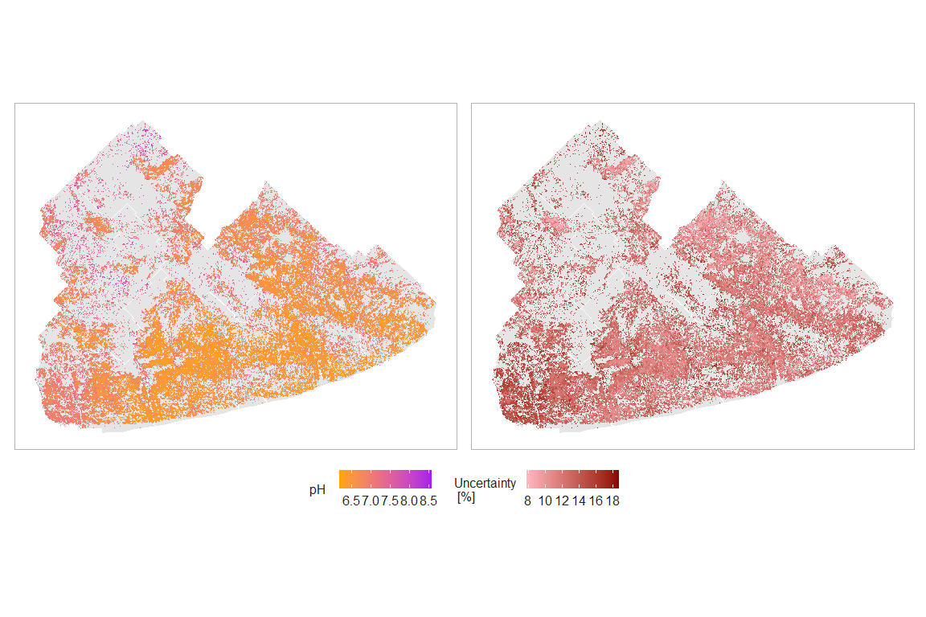

Final map and corresponding uncertainty in percent for ph_0_30

## Accuracy assessment: pH

The section presents the map quality mesaures (i.e. accuracy indicators) associated with pH, the relationship between observed and predicted values and the importance of the single covariates on the model accuracy using the Boruta algorithm.

### Accuracy indicators: pH

Accuracy Indicators: pH

| ME | MAE | RMSE | r | r2 | MEC |
| --- | --- | --- | --- | --- | --- |
| -0.02 | 0.74 | 0.97 | 0.49 | 0.24 | 0.24 |

### Observed vs Predicted: pH

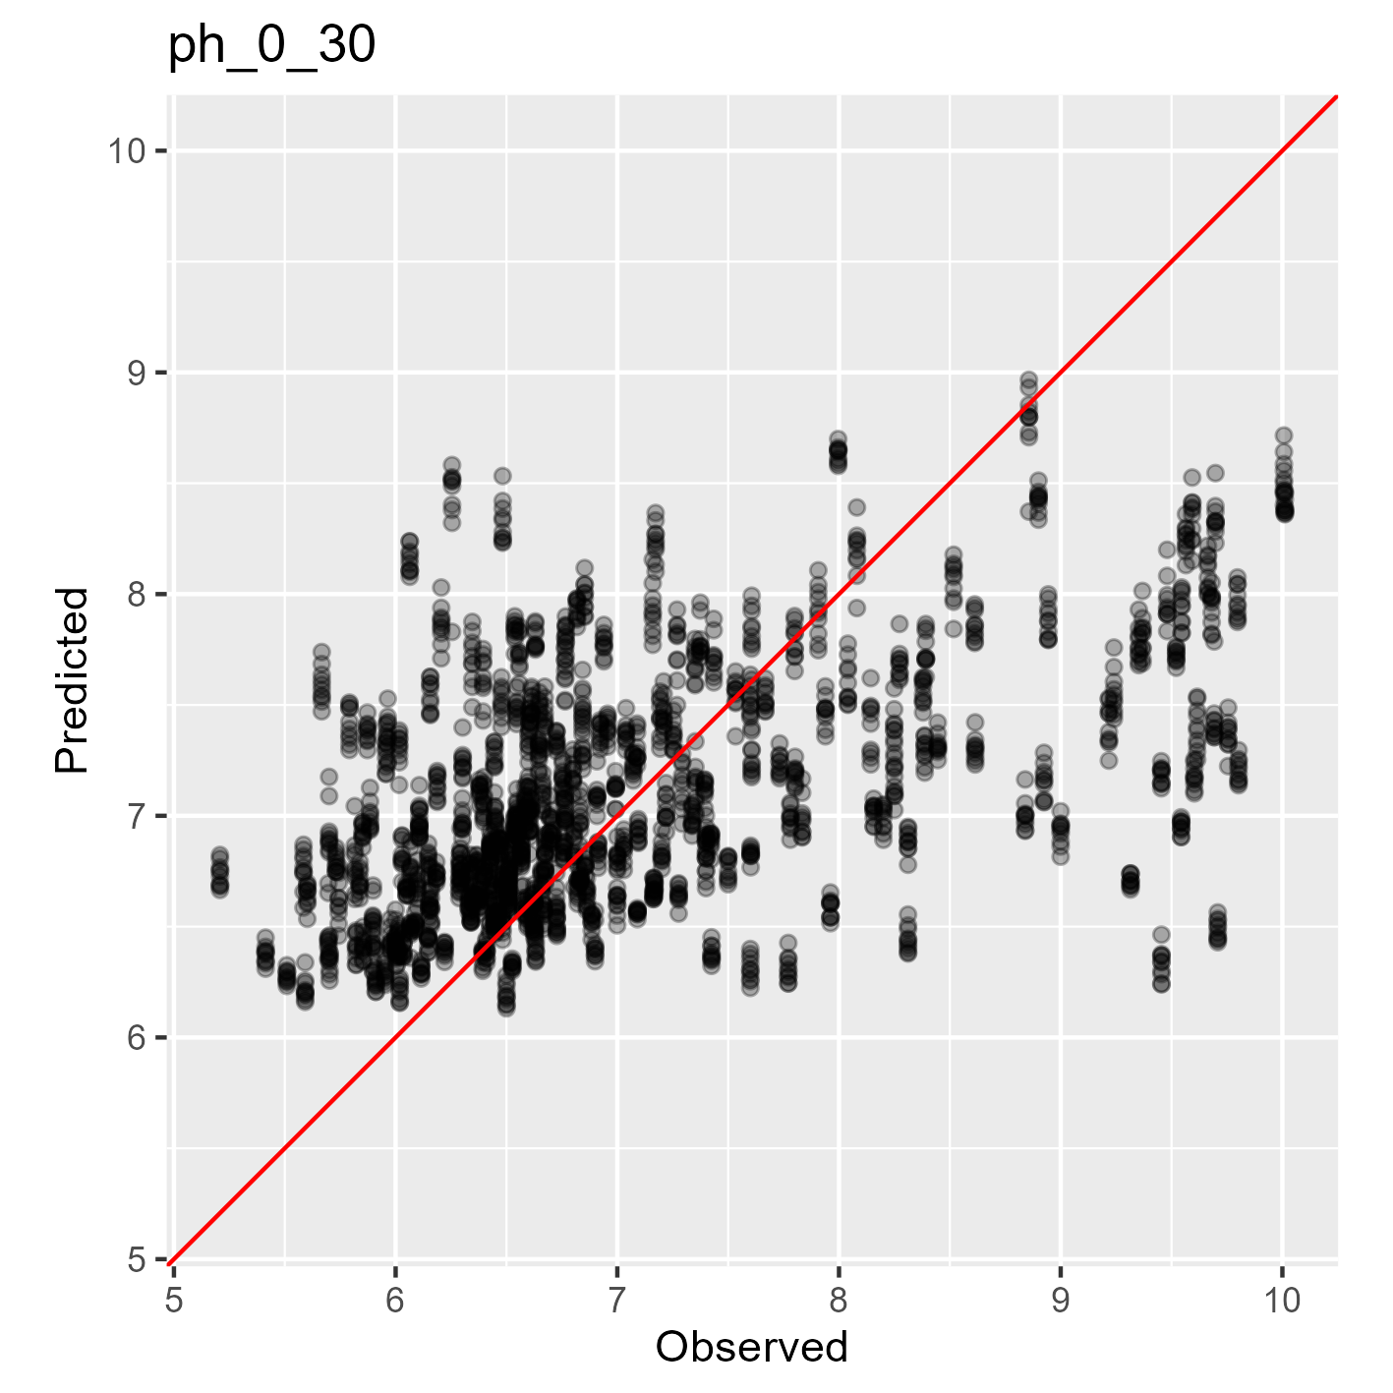

Observed vs Predicted: pH

### Importance of the covariates: pH

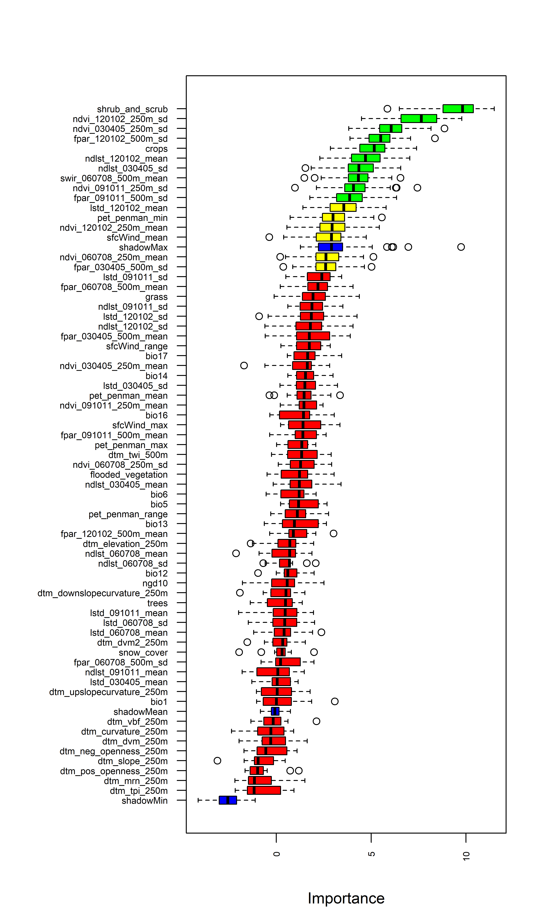

Covariate importance to the final model based on the Boruta algorithm

# Attribute: Available K

This section presents the descriptive statistics of the input data used to calibrate a model to predict Available K, its final output map as well as the corresponding uncertainty in percent.

Overview of the input data used for the Available K soil property map

| mean | min | median | max | Number of points | Unit |
| --- | --- | --- | --- | --- | --- |
| 752.8 | 156.4 | 716.8 | 3804.6 | 378 | ppm |

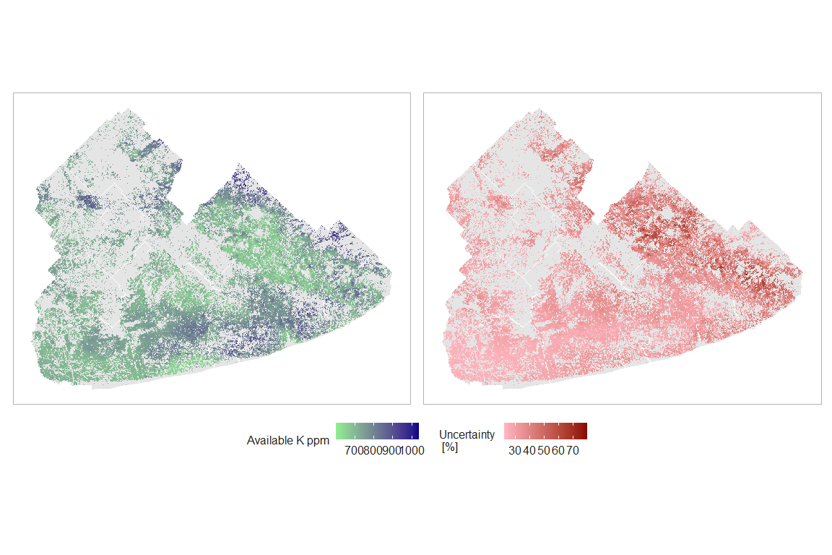

Final map and corresponding uncertainty in percent for k_0_30

## Accuracy assessment: Available K

The section presents the map quality mesaures (i.e. accuracy indicators) associated with Available K, the relationship between observed and predicted values and the importance of the single covariates on the model accuracy using the Boruta algorithm.

### Accuracy indicators: Available K

Accuracy Indicators: Available K

| ME | MAE | RMSE | r | r2 | MEC |
| --- | --- | --- | --- | --- | --- |
| -0.68 | 203.22 | 284.99 | 0.21 | 0.04 | 0.03 |

### Observed vs Predicted: Available K

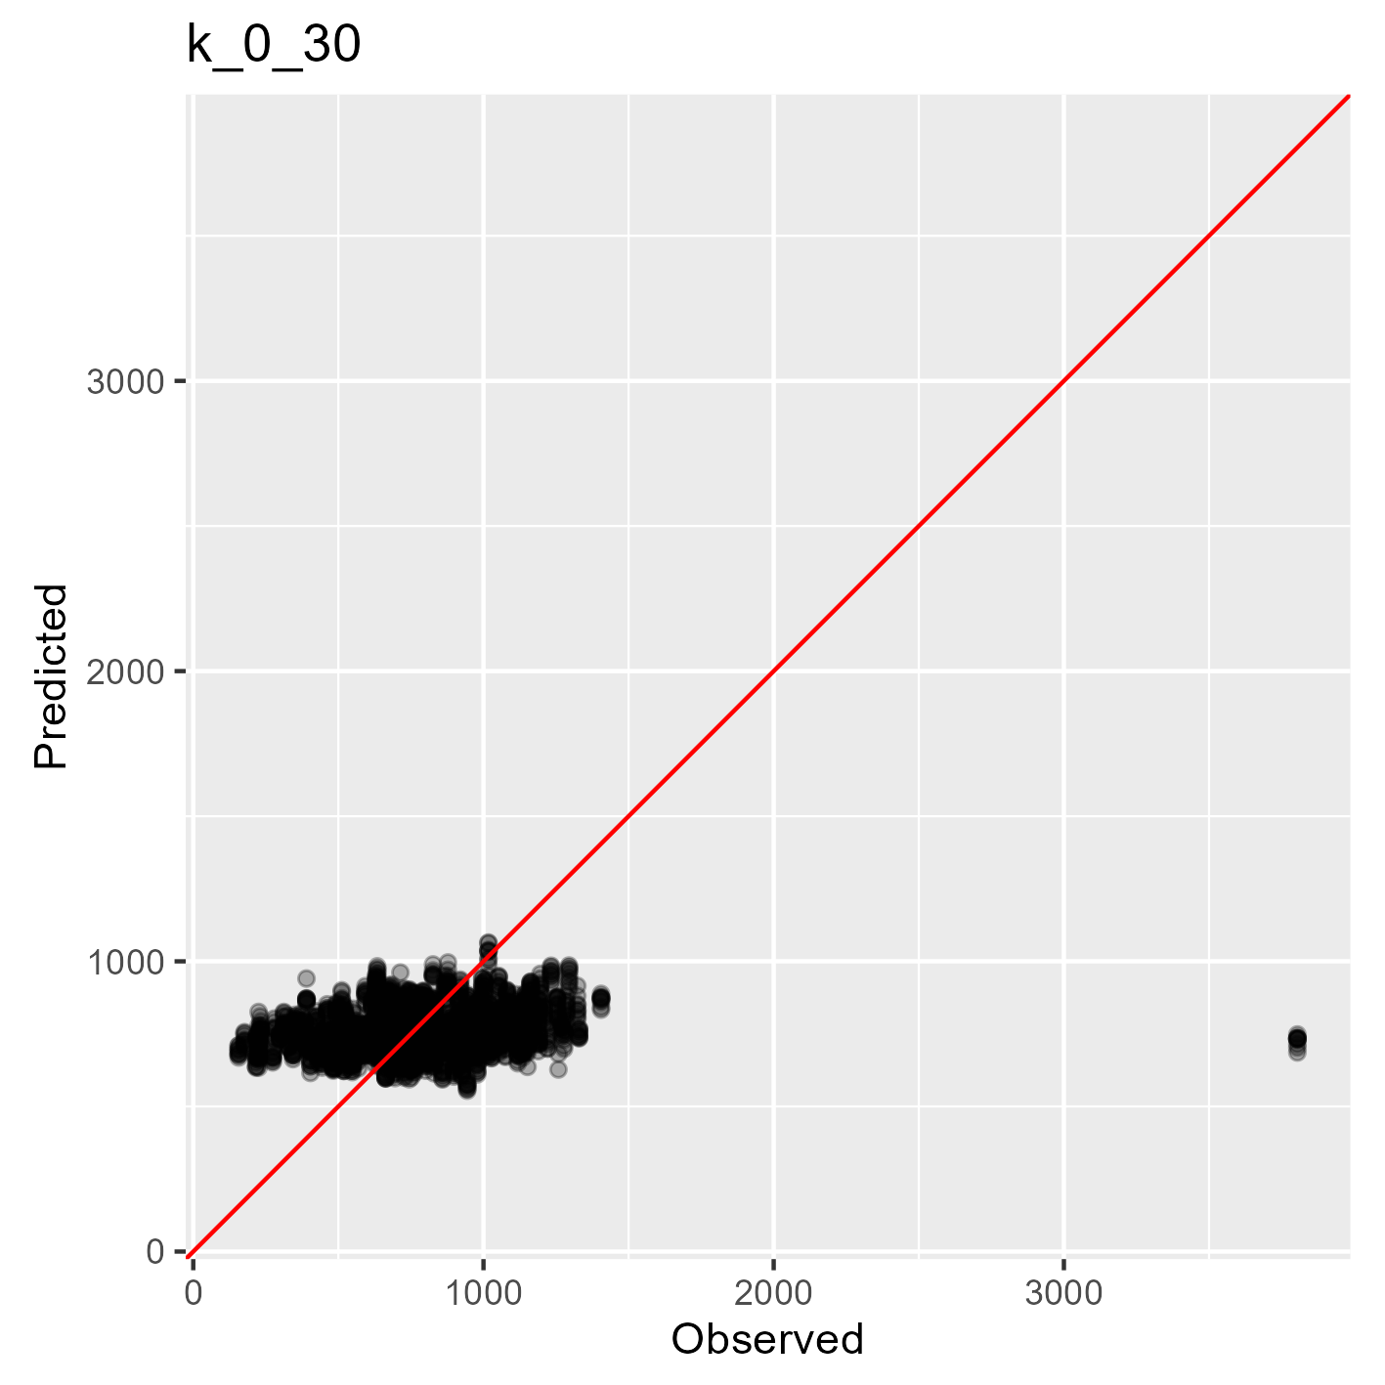

Observed vs Predicted: Available K

### Importance of the covariates: Available K

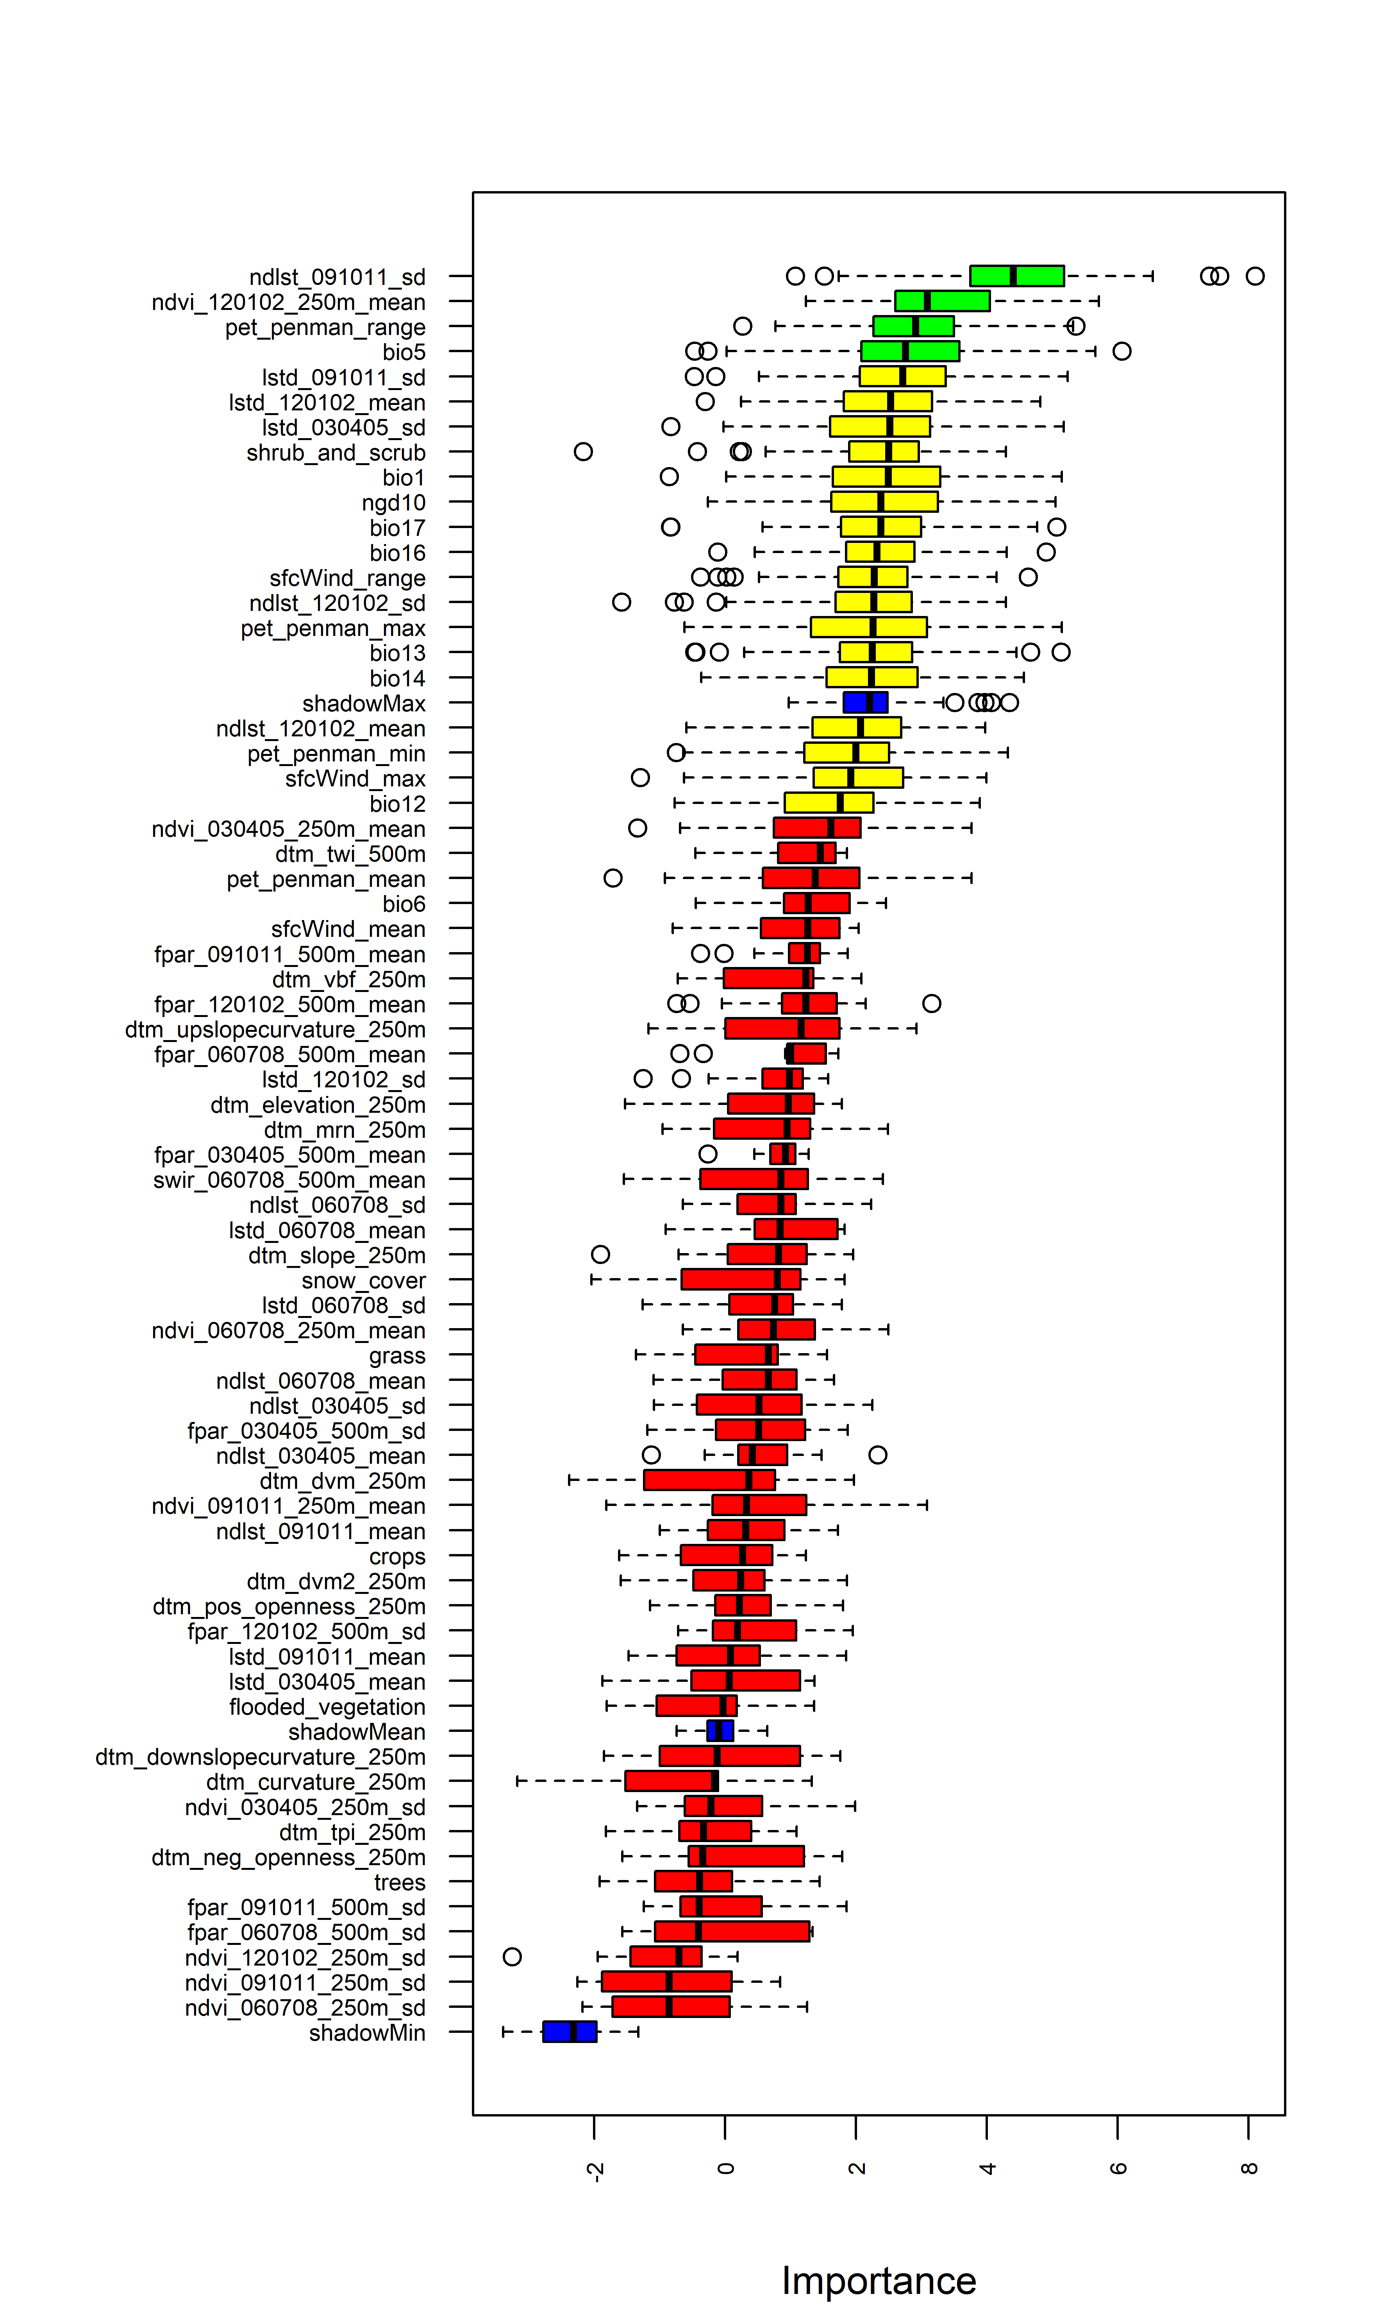

Covariate importance to the final model based on the Boruta algorithm

# Attribute: Soil Organic Carbon

This section presents the descriptive statistics of the input data used to calibrate a model to predict Soil Organic Carbon, its final output map as well as the corresponding uncertainty in percent.

Overview of the input data used for the Soil Organic Carbon soil property map

| mean | min | median | max | Number of points | Unit |
| --- | --- | --- | --- | --- | --- |
| 2.6 | 0.3 | 2.7 | 4.5 | 263 | % |

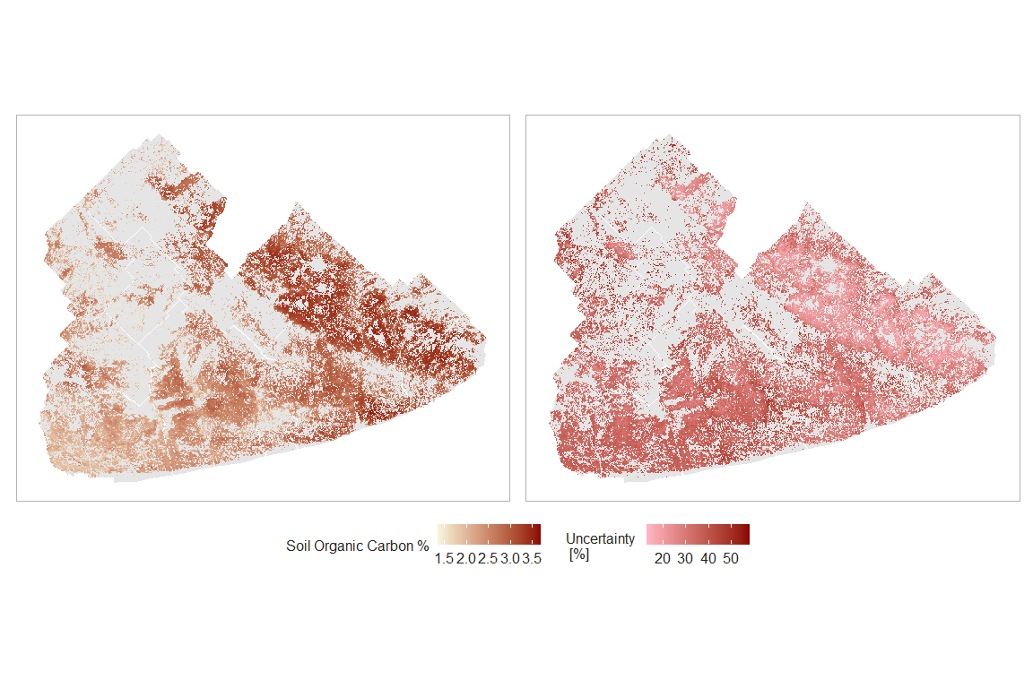

Final map and corresponding uncertainty in percent for soc_0_30

## Accuracy assessment: Soil Organic Carbon

The section presents the map quality mesaures (i.e. accuracy indicators) associated with Soil Organic Carbon, the relationship between observed and predicted values and the importance of the single covariates on the model accuracy using the Boruta algorithm.

### Accuracy indicators: Soil Organic Carbon

Accuracy Indicators: Soil Organic Carbon

| ME | MAE | RMSE | r | r2 | MEC |
| --- | --- | --- | --- | --- | --- |
| 0.01 | 0.69 | 0.85 | 0.49 | 0.24 | 0.24 |

### Observed vs Predicted: Soil Organic Carbon

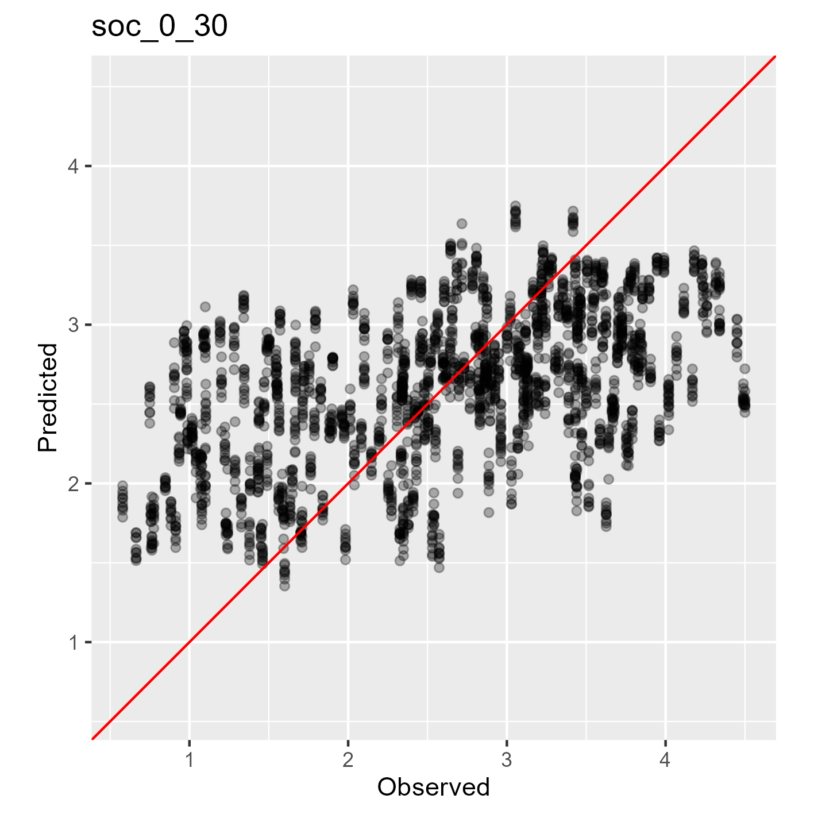

Observed vs Predicted: Soil Organic Carbon

### Importance of the covariates: Soil Organic Carbon

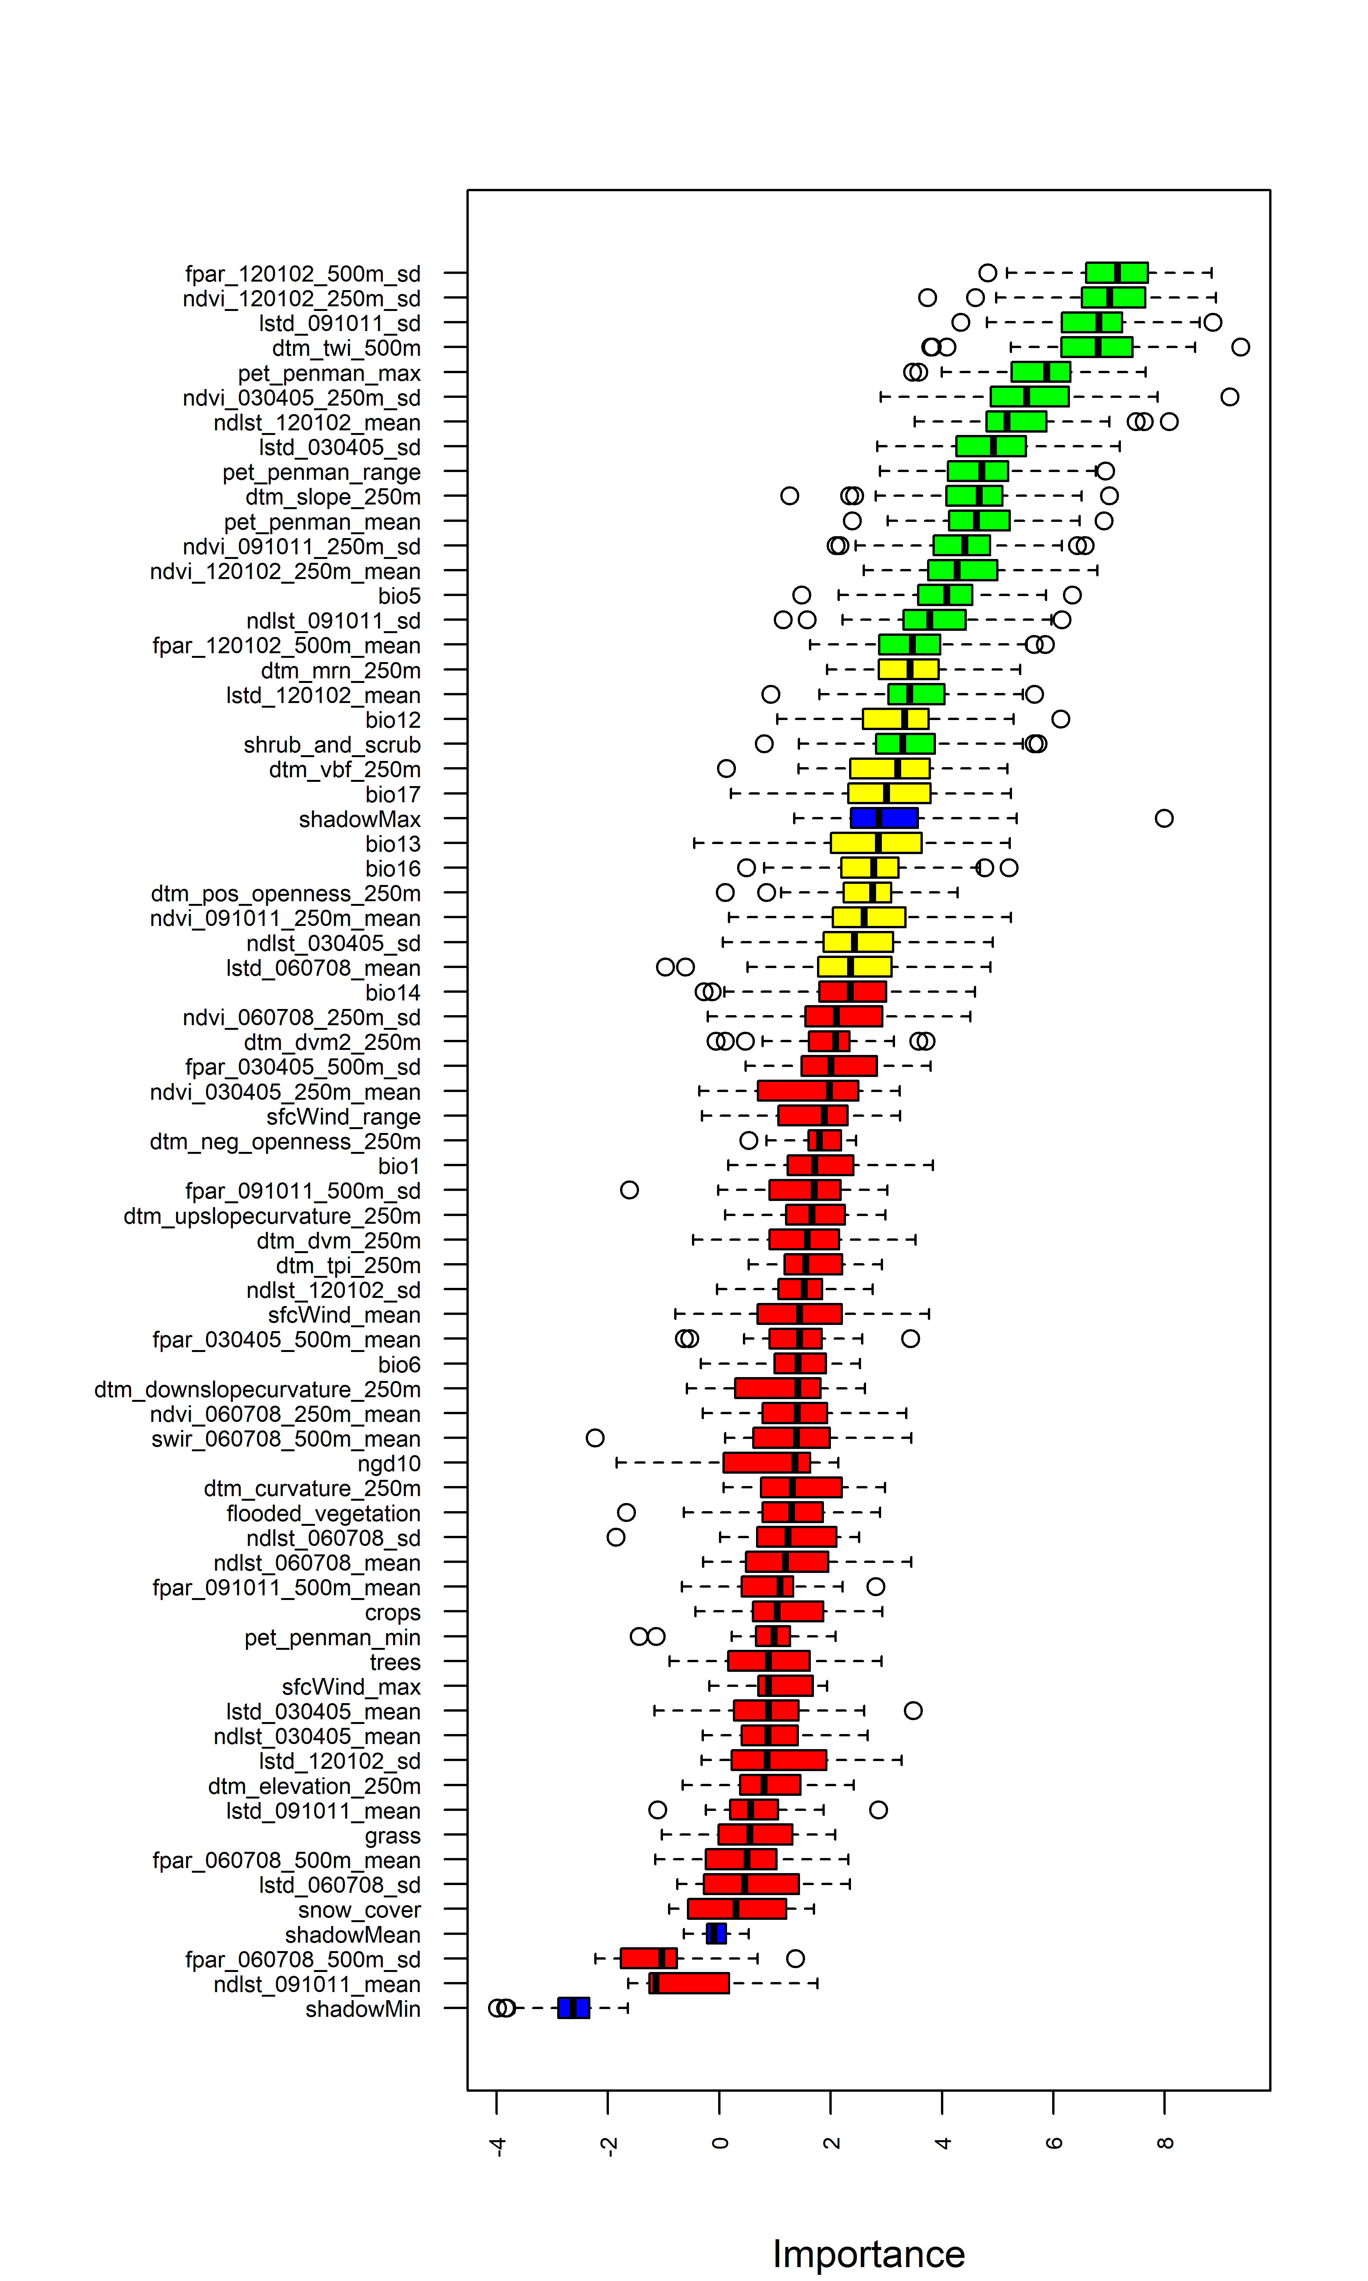

Covariate importance to the final model based on the Boruta algorithm

# Attribute: Bulk density

This section presents the descriptive statistics of the input data used to calibrate a model to predict Bulk density, its final output map as well as the corresponding uncertainty in percent.

Overview of the input data used for the Bulk density soil property map

| mean | min | median | max | Number of points | Unit |
| --- | --- | --- | --- | --- | --- |
| 1.3 | 1 | 1.2 | 1.7 | 263 | g/cm3 |

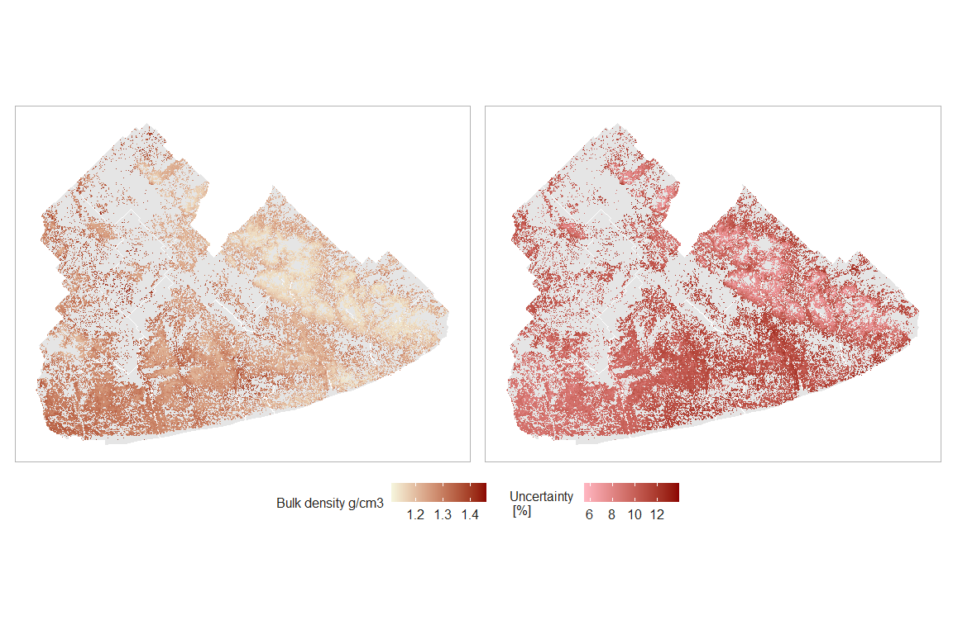

Final map and corresponding uncertainty in percent for bd_0_30

## Accuracy assessment: Bulk density

The section presents the map quality mesaures (i.e. accuracy indicators) associated with Bulk density, the relationship between observed and predicted values and the importance of the single covariates on the model accuracy using the Boruta algorithm.

### Accuracy indicators: Bulk density

Accuracy Indicators: Bulk density

| ME | MAE | RMSE | r | r2 | MEC |
| --- | --- | --- | --- | --- | --- |
| 0 | 0.11 | 0.13 | 0.48 | 0.23 | 0.23 |

### Observed vs Predicted: Bulk density

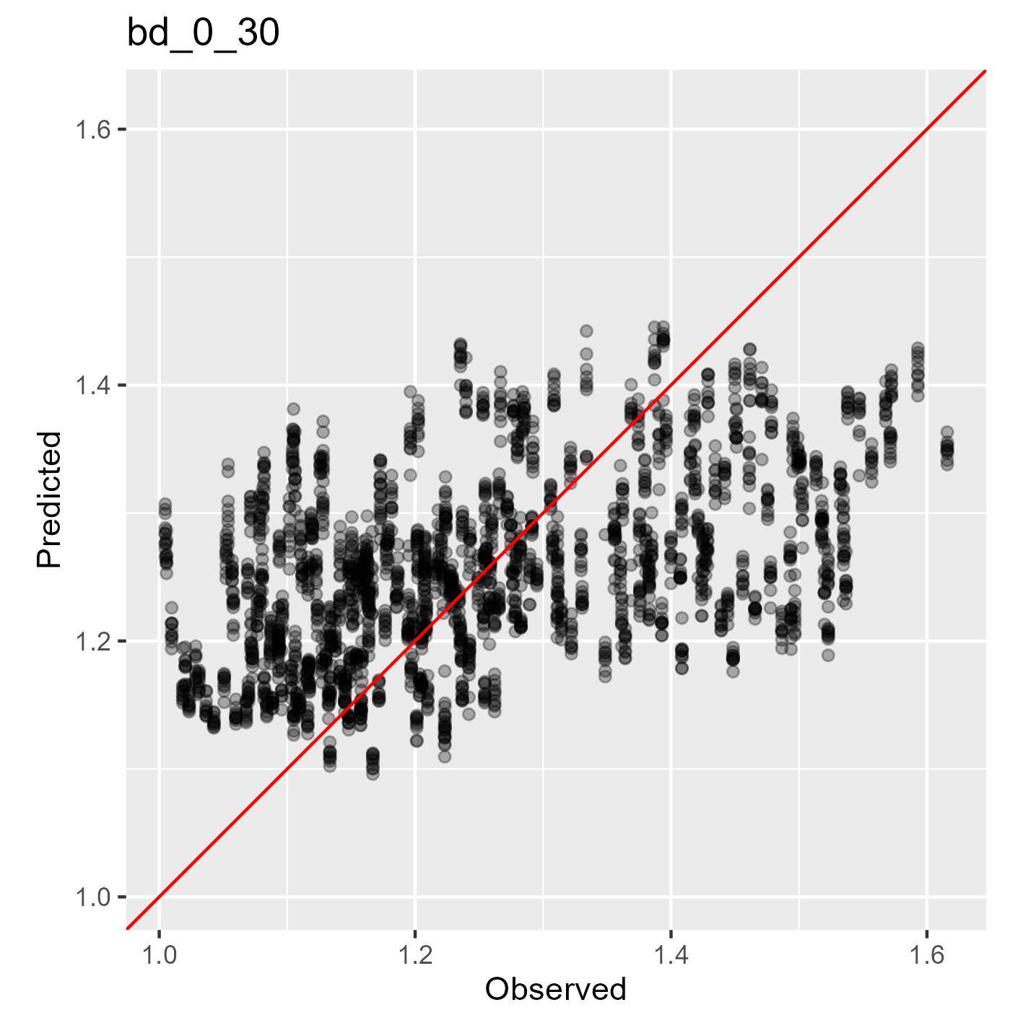

Observed vs Predicted: Bulk density

### Importance of the covariates: Bulk density

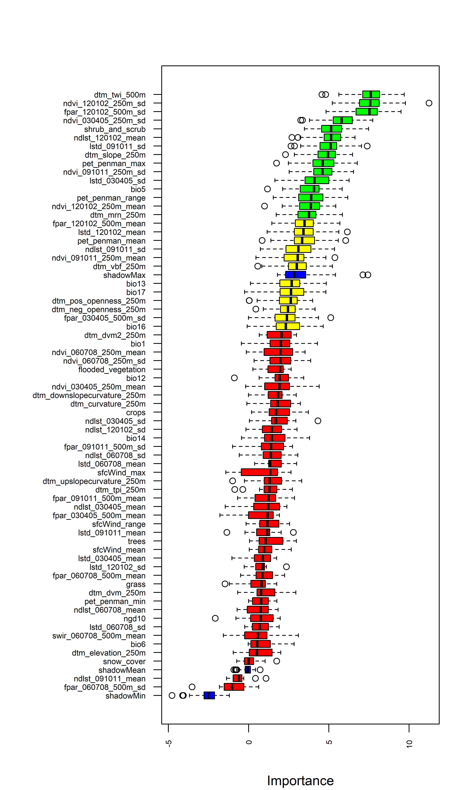

Covariate importance to the final model based on the Boruta algorithm

# Attribute: Cation Exchange Capacity

This section presents the descriptive statistics of the input data used to calibrate a model to predict Cation Exchange Capacity, its final output map as well as the corresponding uncertainty in percent.

Overview of the input data used for the Cation Exchange Capacity soil property map

| mean | min | median | max | Number of points | Unit |
| --- | --- | --- | --- | --- | --- |
| 25 | 3 | 24.9 | 44.4 | 255 | cmol(c)/kg |

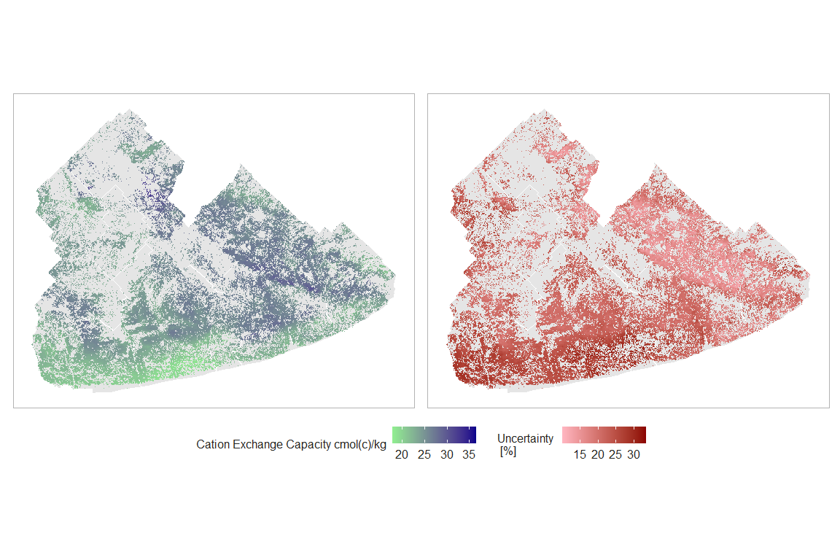

Final map and corresponding uncertainty in percent for cec_0_30

## Accuracy assessment: Cation Exchange Capacity

The section presents the map quality mesaures (i.e. accuracy indicators) associated with Cation Exchange Capacity, the relationship between observed and predicted values and the importance of the single covariates on the model accuracy using the Boruta algorithm.

### Accuracy indicators: Cation Exchange Capacity

Accuracy Indicators: Cation Exchange Capacity

| ME | MAE | RMSE | r | r2 | MEC |
| --- | --- | --- | --- | --- | --- |
| -0.05 | 3.88 | 4.93 | 0.45 | 0.2 | 0.2 |

### Observed vs Predicted: Cation Exchange Capacity

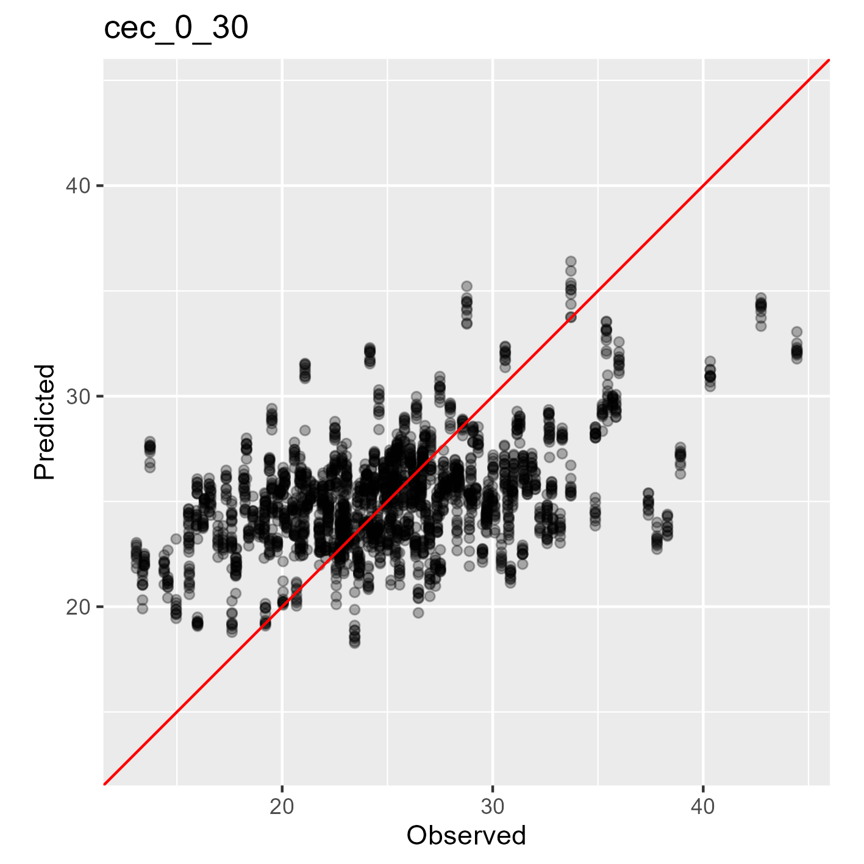

Observed vs Predicted: Cation Exchange Capacity

### Importance of the covariates: Cation Exchange Capacity

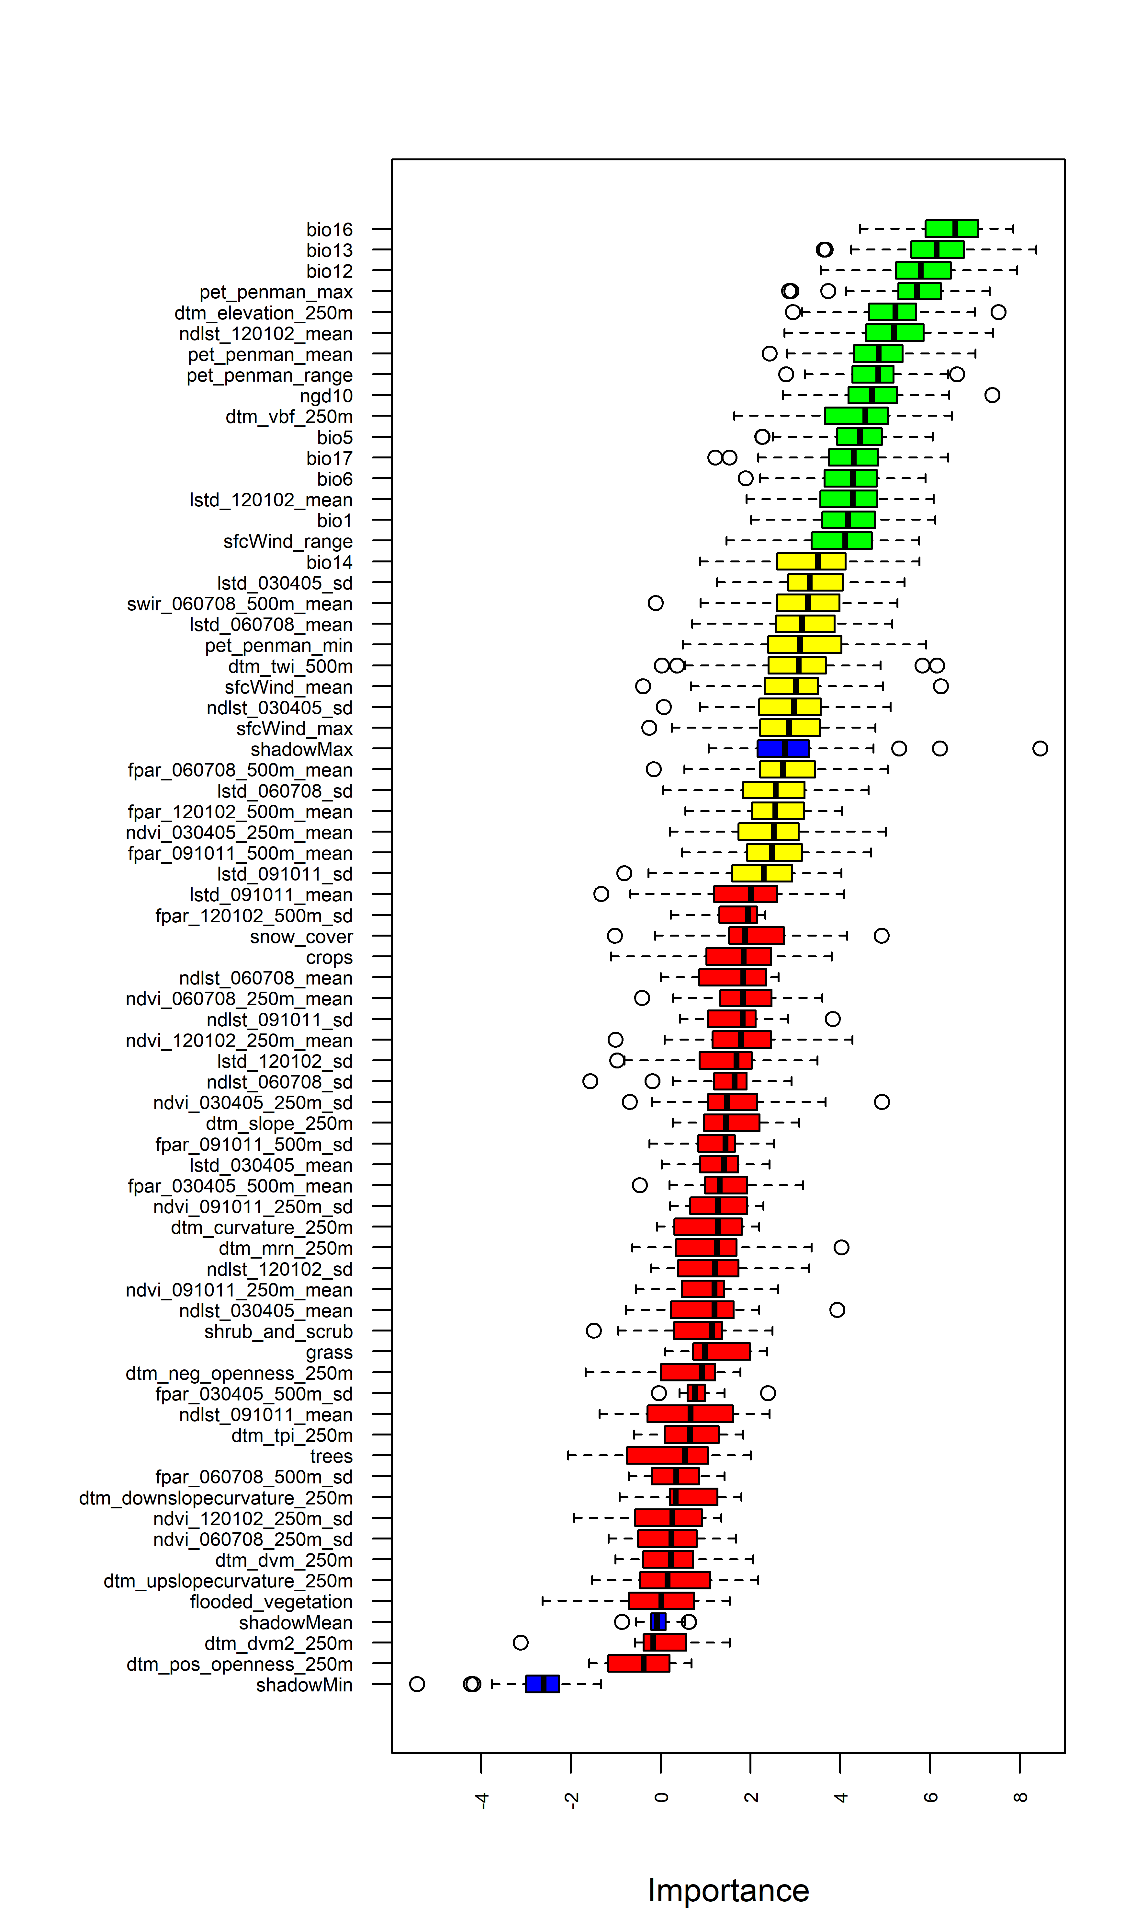

Covariate importance to the final model based on the Boruta algorithm

# Attribute: Available P

This section presents the descriptive statistics of the input data used to calibrate a model to predict Available P, its final output map as well as the corresponding uncertainty in percent.

Overview of the input data used for the Available P soil property map

| mean | min | median | max | Number of points | Unit |
| --- | --- | --- | --- | --- | --- |
| 15.1 | 4.2 | 13.5 | 54.6 | 119 | ppm |

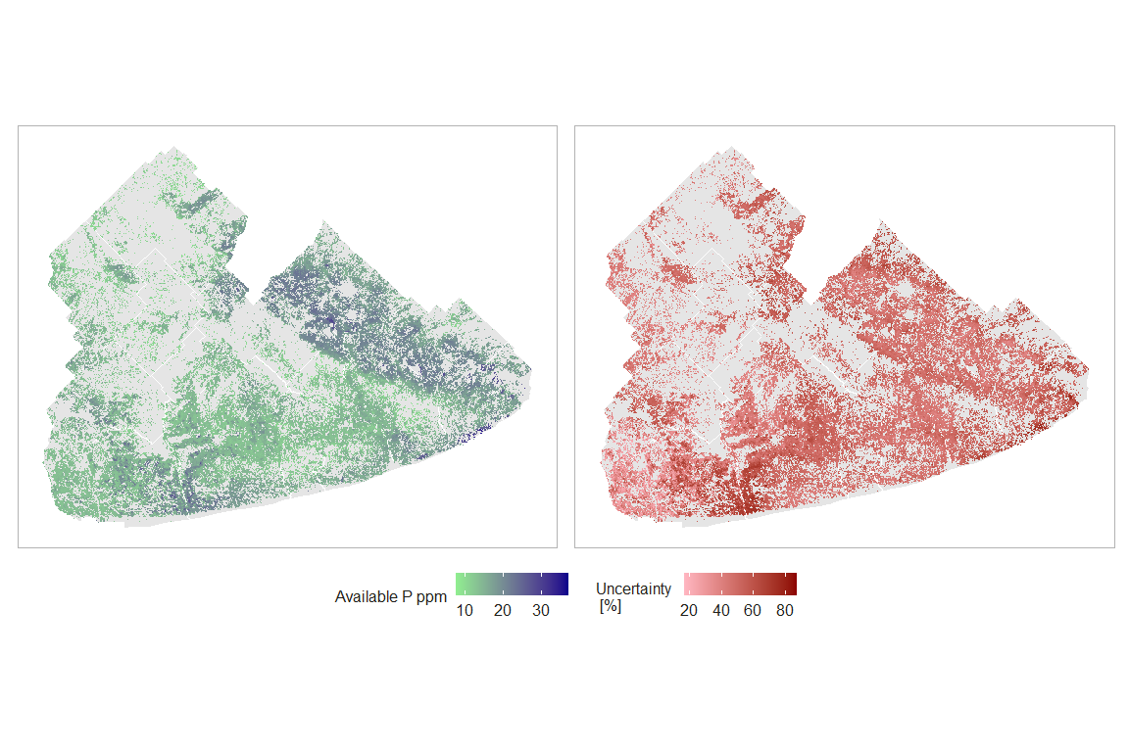

Final map and corresponding uncertainty in percent for p_0_30

## Accuracy assessment: Available P

The section presents the map quality mesaures (i.e. accuracy indicators) associated with Available P, the relationship between observed and predicted values and the importance of the single covariates on the model accuracy using the Boruta algorithm.

### Accuracy indicators: Available P

Accuracy Indicators: Available P

| ME | MAE | RMSE | r | r2 | MEC |
| --- | --- | --- | --- | --- | --- |
| 0.07 | 5.39 | 7.84 | 0.36 | 0.13 | 0.13 |

### Observed vs Predicted: Available P

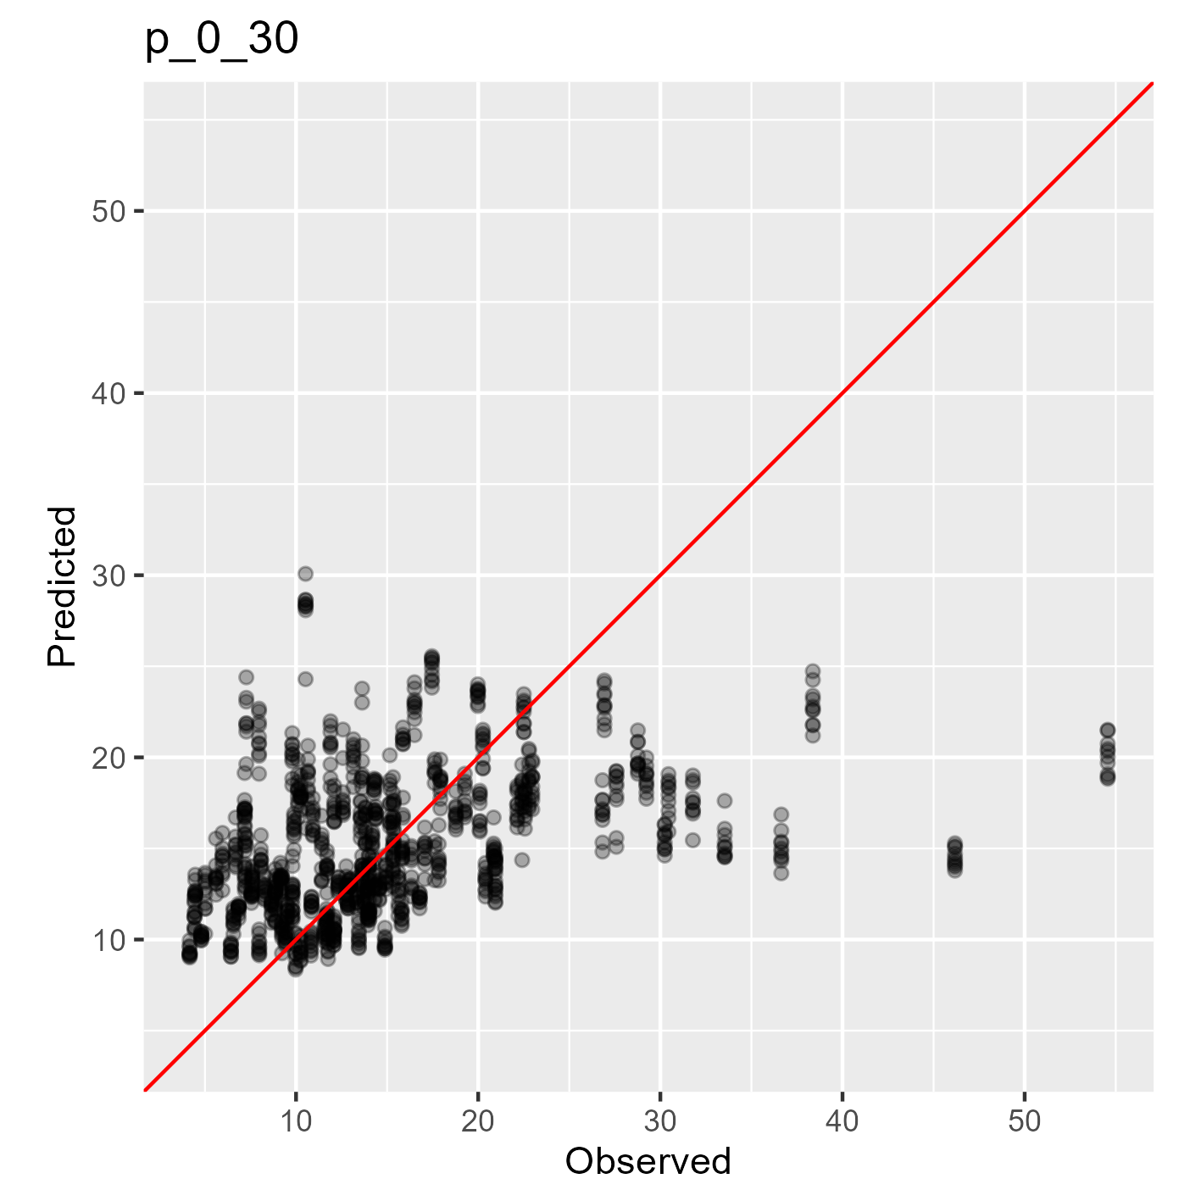

Observed vs Predicted: Available P

### Importance of the covariates: Available P

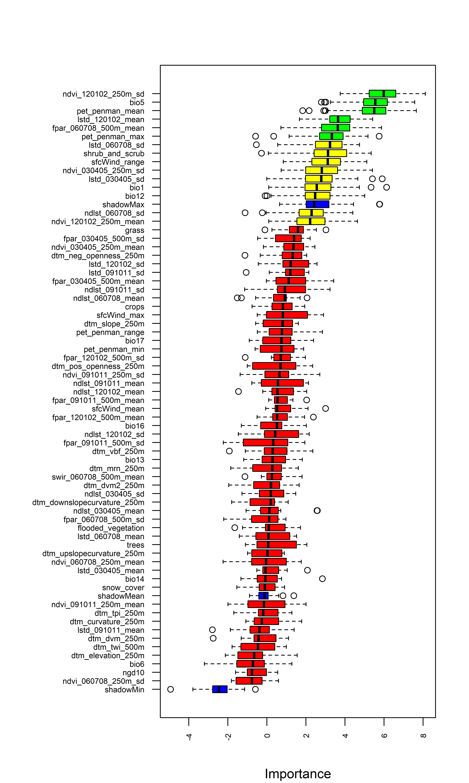

Covariate importance to the final model based on the Boruta algorithm

# Attribute: Total N

This section presents the descriptive statistics of the input data used to calibrate a model to predict Total N, its final output map as well as the corresponding uncertainty in percent.

Overview of the input data used for the Total N soil property map

| mean | min | median | max | Number of points | Unit |
| --- | --- | --- | --- | --- | --- |
| 2342.1 | 938.2 | 2398.4 | 3378.1 | 119 | ppm |

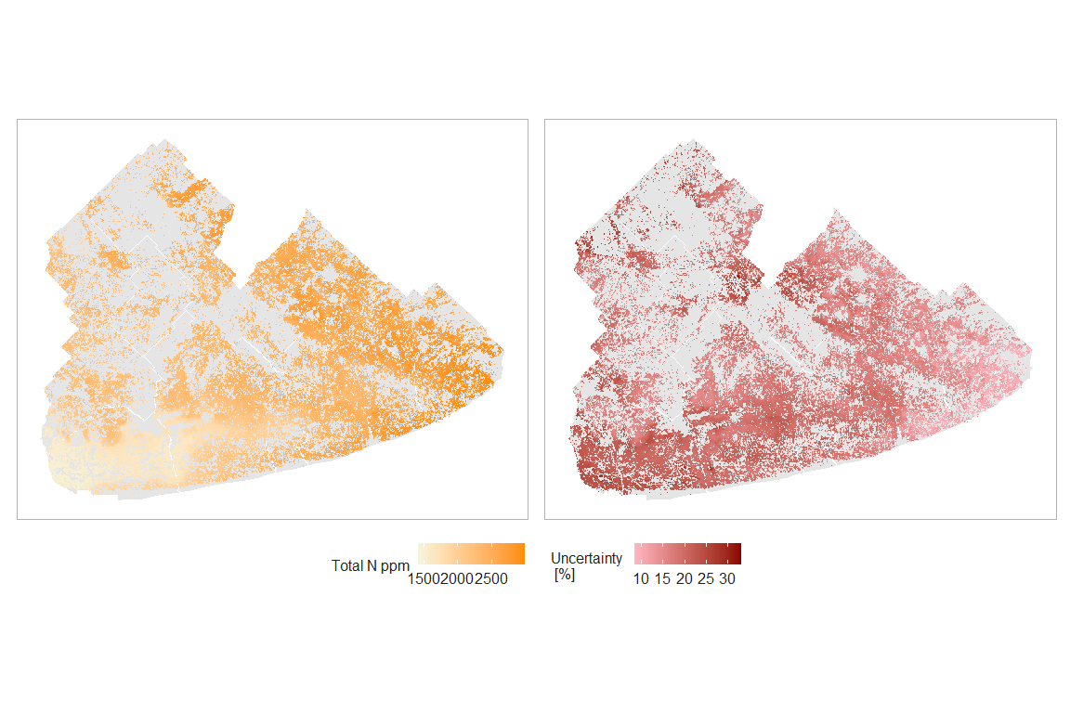

Final map and corresponding uncertainty in percent for n_0_30

## Accuracy assessment: Total N

The section presents the map quality mesaures (i.e. accuracy indicators) associated with Total N, the relationship between observed and predicted values and the importance of the single covariates on the model accuracy using the Boruta algorithm.

### Accuracy indicators: Total N

Accuracy Indicators: Total N

| ME | MAE | RMSE | r | r2 | MEC |
| --- | --- | --- | --- | --- | --- |
| 4.06 | 278.55 | 375.4 | 0.7 | 0.49 | 0.49 |

### Observed vs Predicted: Total N

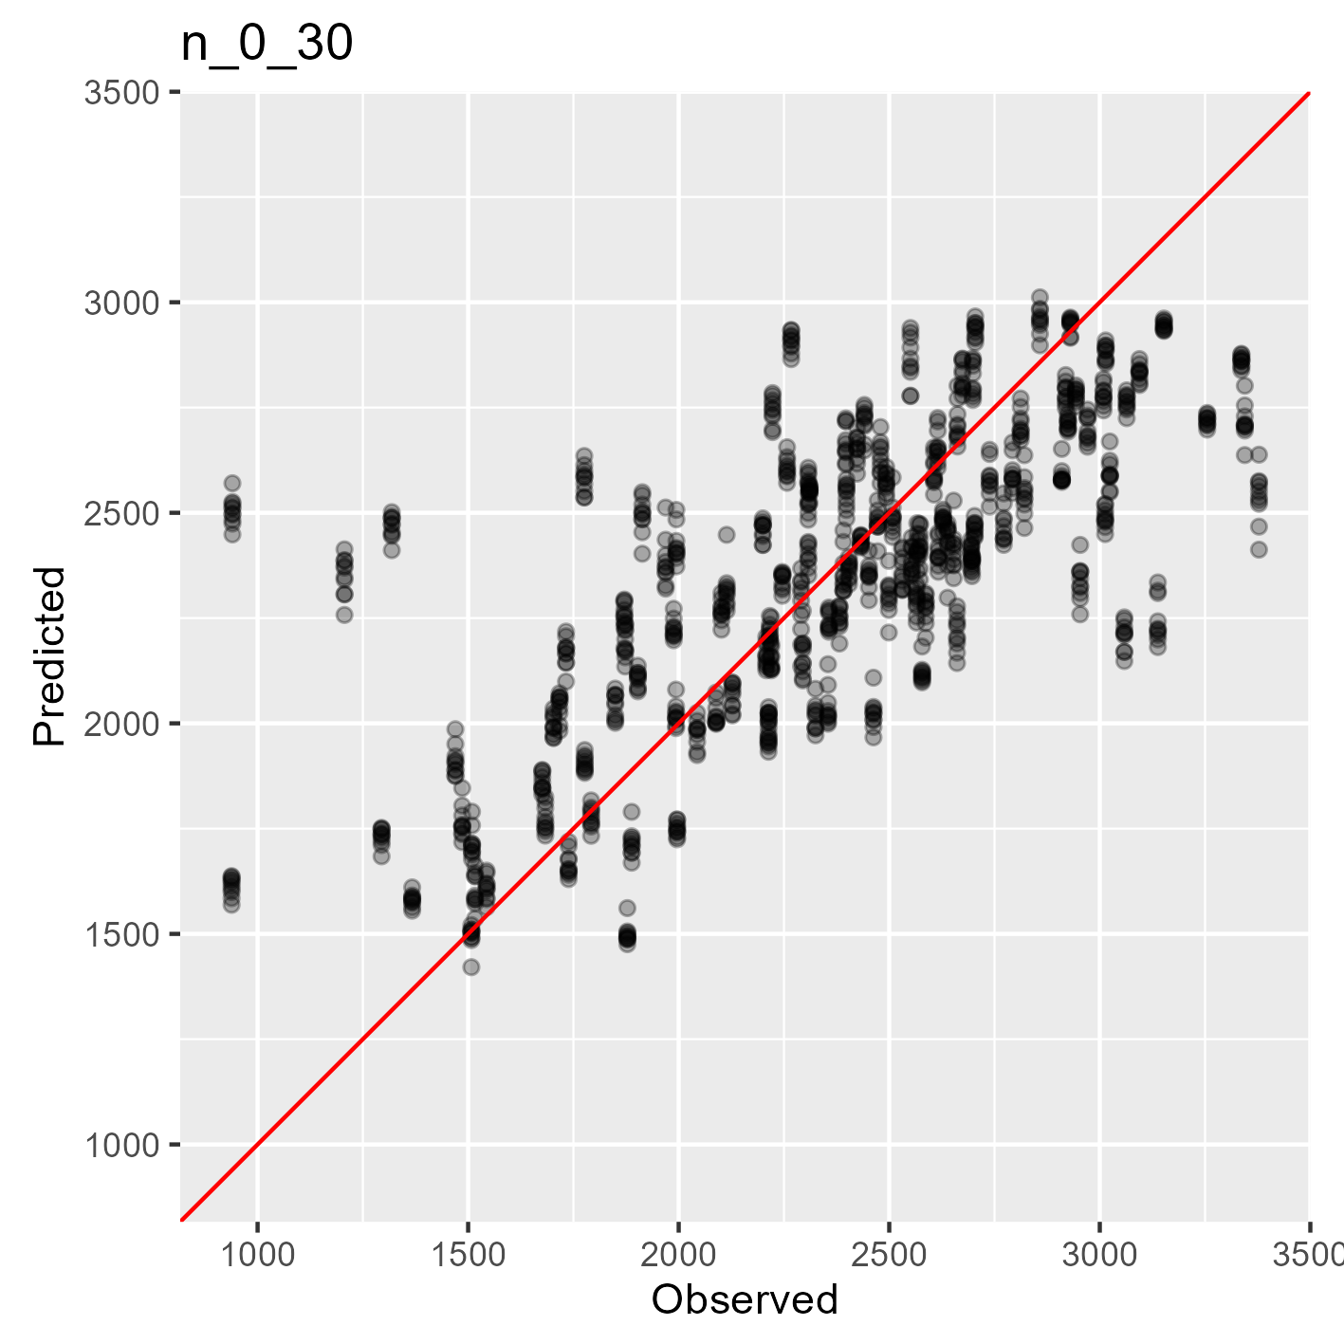

Observed vs Predicted: Total N

### Importance of the covariates: Total N

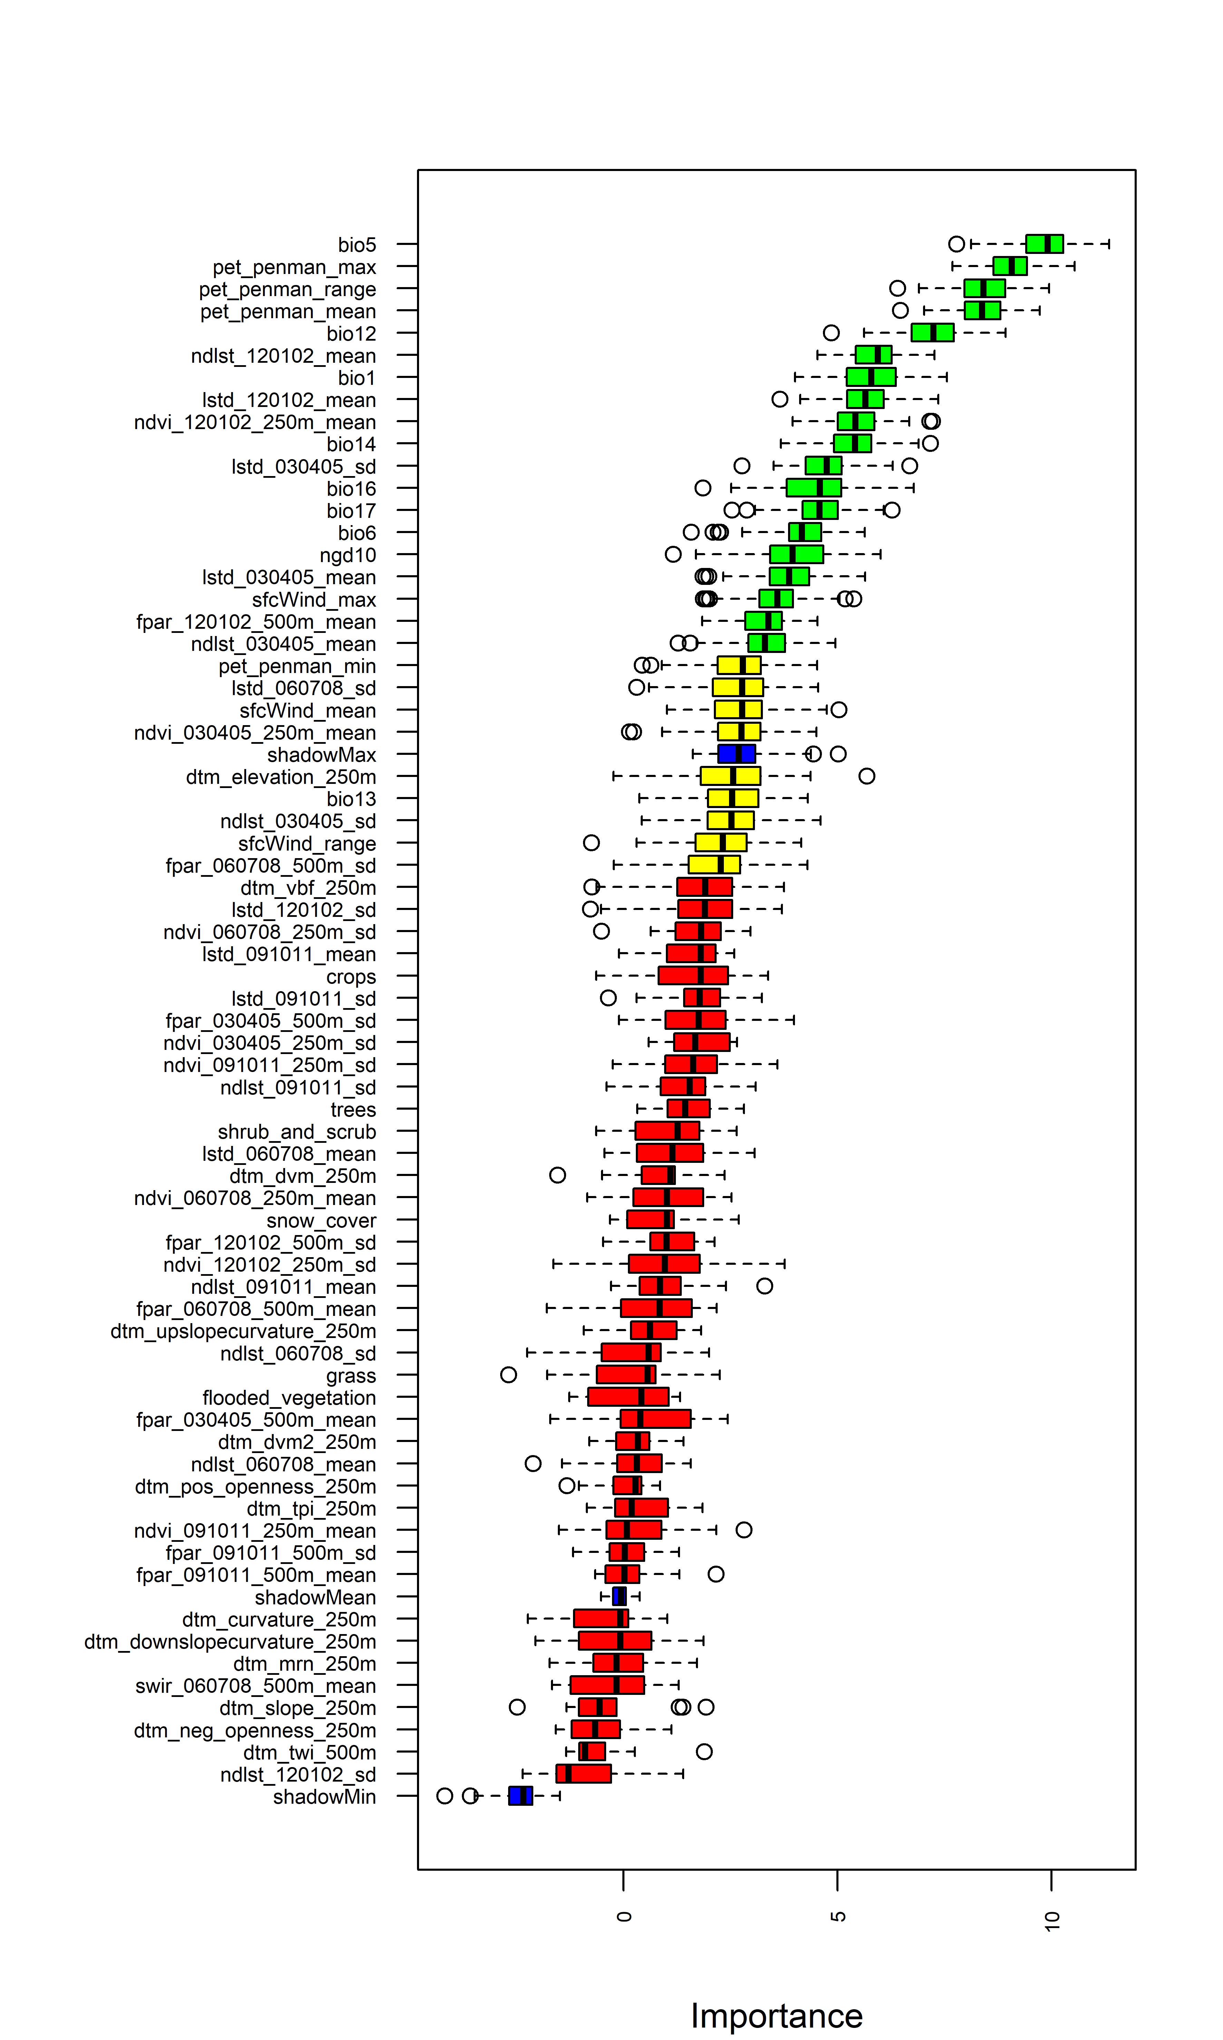

Covariate importance to the final model based on the Boruta algorithm

# Attribute: Clay

This section presents the descriptive statistics of the input data used to calibrate a model to predict Clay, its final output map as well as the corresponding uncertainty in percent.

Overview of the input data used for the Clay soil property map

| mean | min | median | max | Number of points | Unit |
| --- | --- | --- | --- | --- | --- |
| 26 | 0 | 25.7 | 100 | 253 | % |

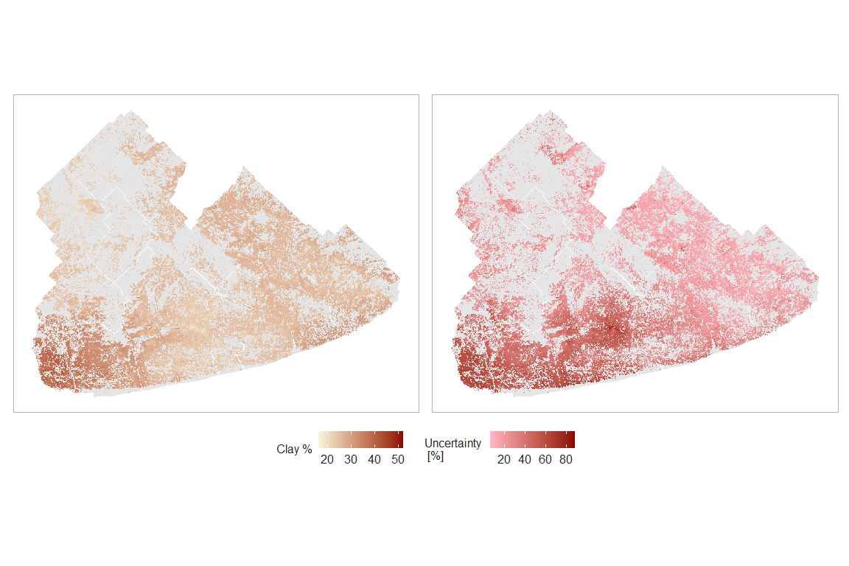

Final map and corresponding uncertainty in percent for clay_0_30

## Accuracy assessment: Clay

The section presents the map quality mesaures (i.e. accuracy indicators) associated with Clay, the relationship between observed and predicted values and the importance of the single covariates on the model accuracy using the Boruta algorithm.

### Accuracy indicators: Clay

Accuracy Indicators: Clay

| ME | MAE | RMSE | r | r2 | MEC |
| --- | --- | --- | --- | --- | --- |
| 0.15 | 3.21 | 6.16 | 0.33 | 0.11 | 0.11 |

### Observed vs Predicted: Clay

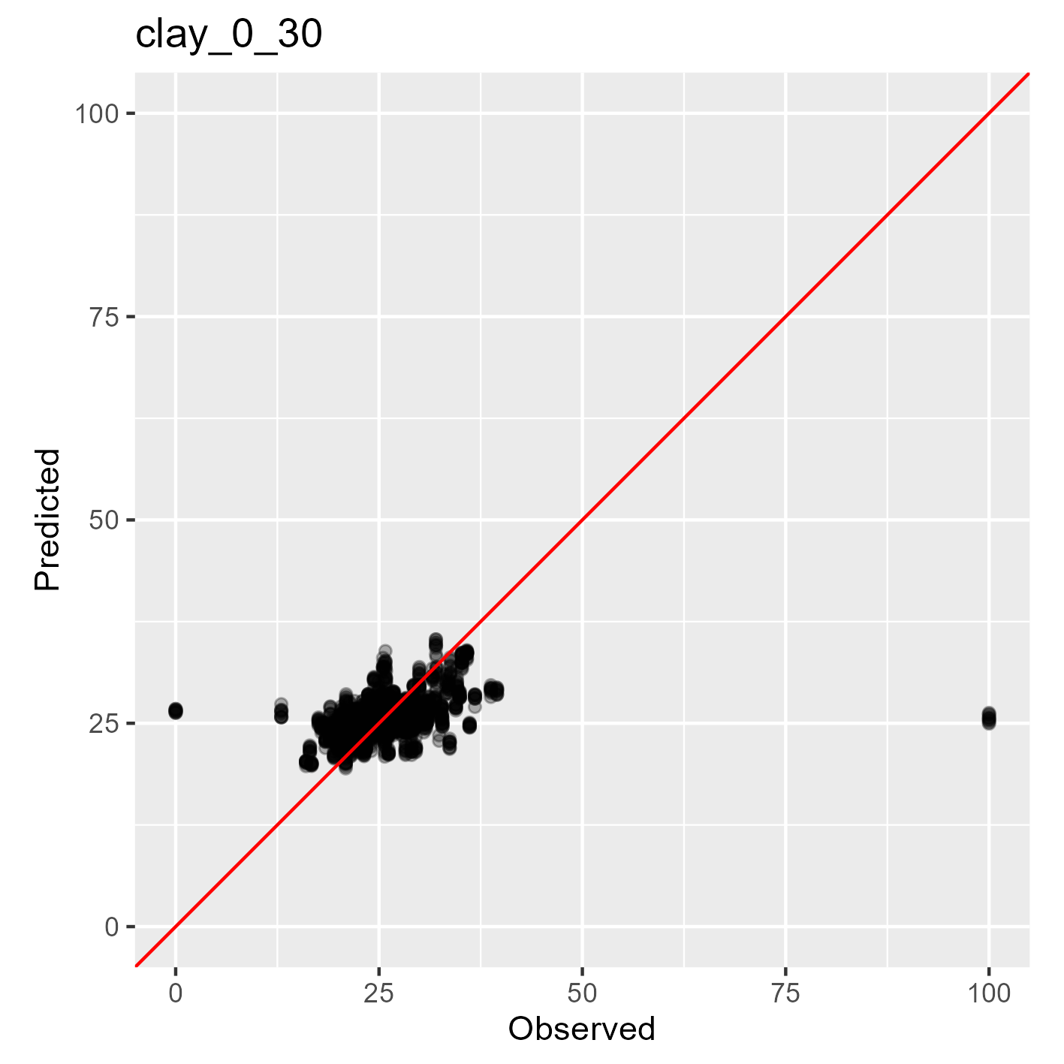

Observed vs Predicted: Clay

### Importance of the covariates: Clay

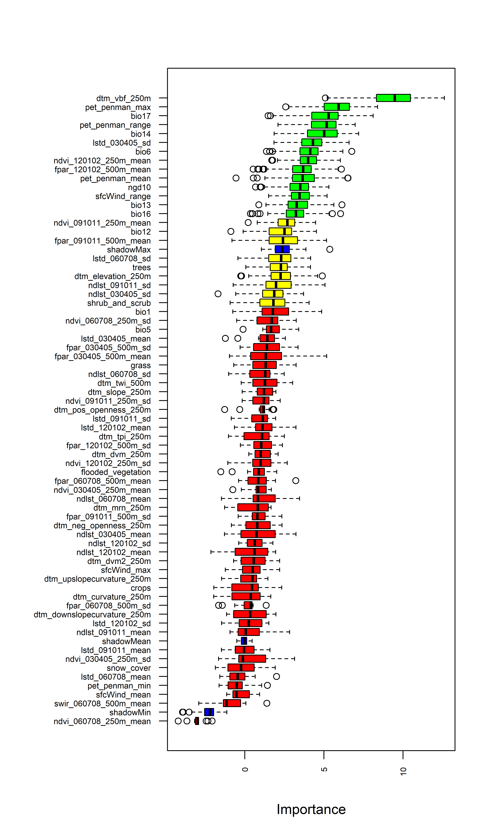

Covariate importance to the final model based on the Boruta algorithm

# Attribute: Sand

This section presents the descriptive statistics of the input data used to calibrate a model to predict Sand, its final output map as well as the corresponding uncertainty in percent.

Overview of the input data used for the Sand soil property map

| mean | min | median | max | Number of points | Unit |
| --- | --- | --- | --- | --- | --- |
| 40 | 0 | 40 | 72 | 253 | % |

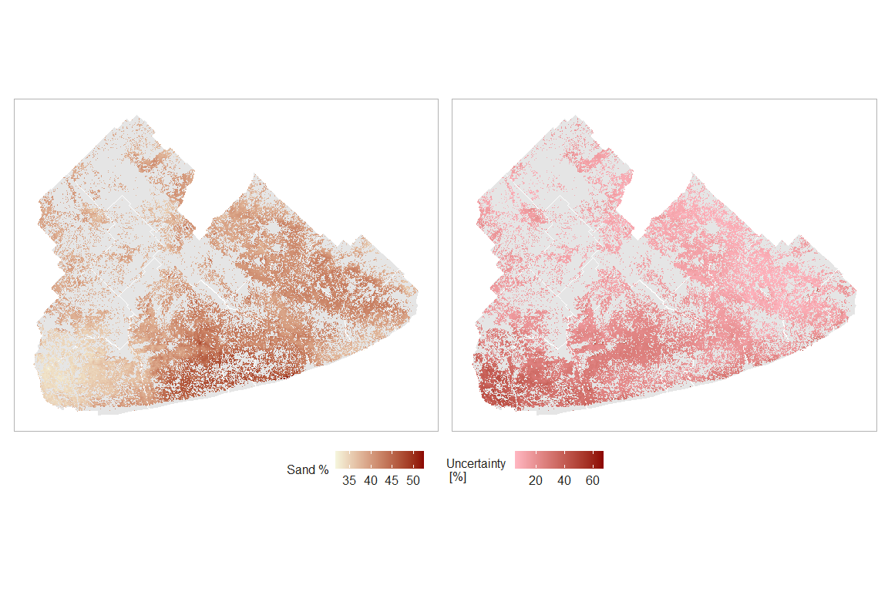

Final map and corresponding uncertainty in percent for sand_0_30

## Accuracy assessment: Sand

The section presents the map quality mesaures (i.e. accuracy indicators) associated with Sand, the relationship between observed and predicted values and the importance of the single covariates on the model accuracy using the Boruta algorithm.

### Accuracy indicators: Sand

Accuracy Indicators: Sand

| ME | MAE | RMSE | r | r2 | MEC |
| --- | --- | --- | --- | --- | --- |
| -0.07 | 3.32 | 5.79 | 0.43 | 0.18 | 0.18 |

### Observed vs Predicted: Sand

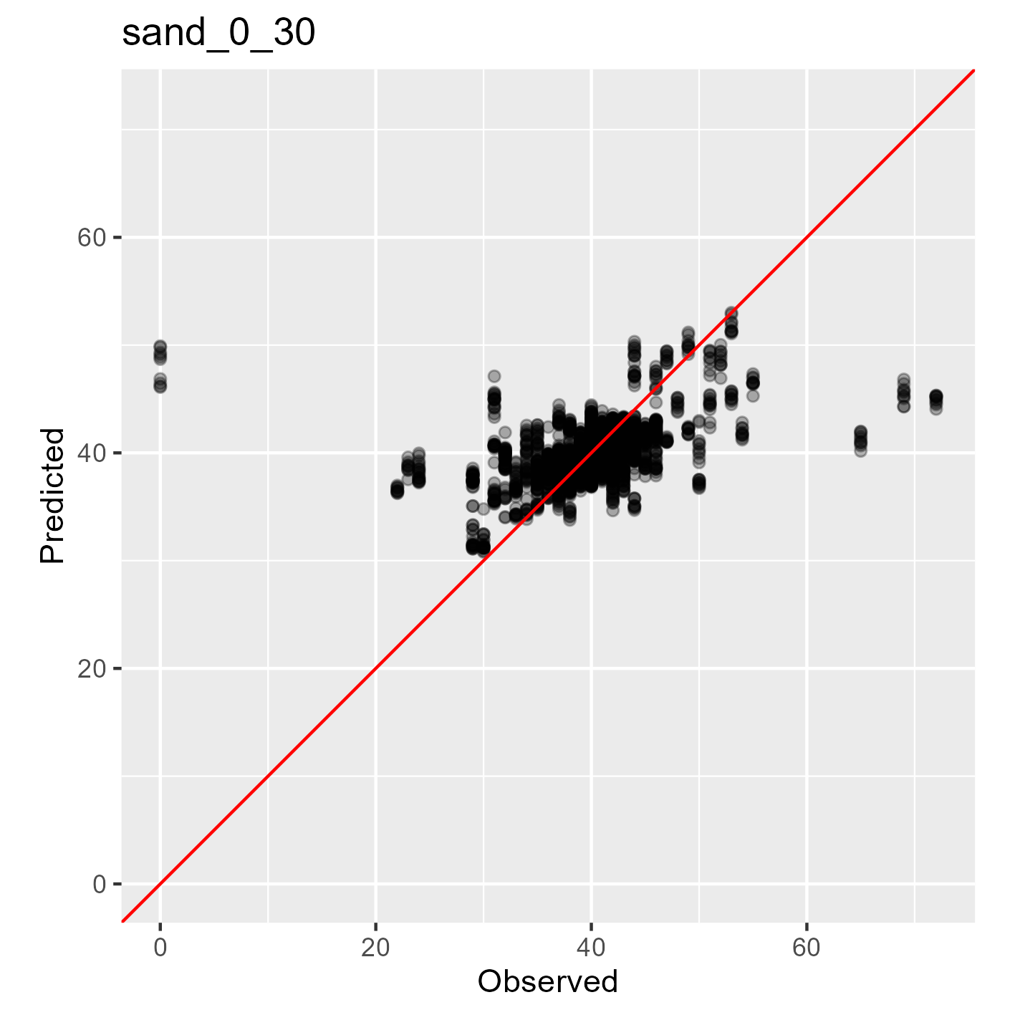

Observed vs Predicted: Sand

### Importance of the covariates: Sand

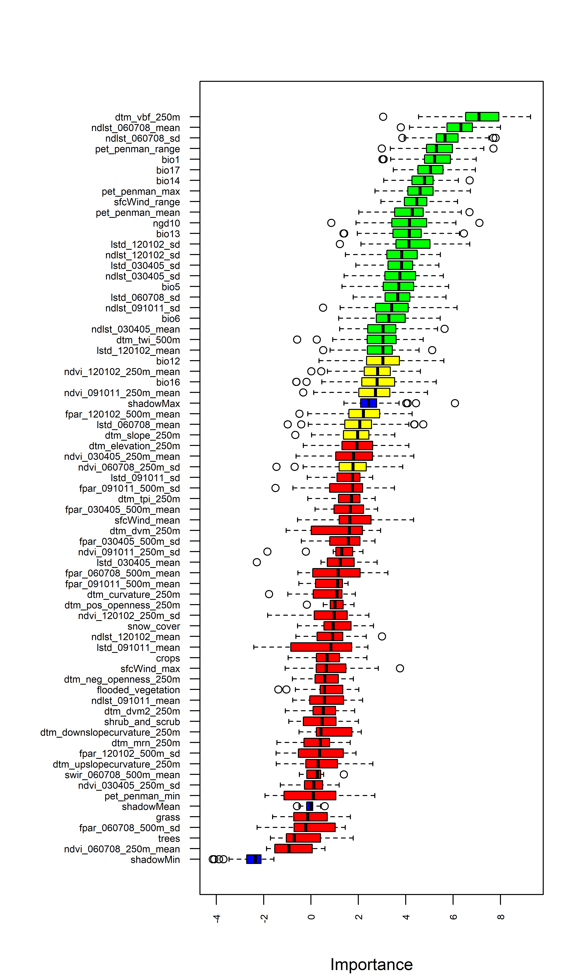

Covariate importance to the final model based on the Boruta algorithm

# Attribute: Silt

This section presents the descriptive statistics of the input data used to calibrate a model to predict Silt, its final output map as well as the corresponding uncertainty in percent.

Overview of the input data used for the Silt soil property map

| mean | min | median | max | Number of points | Unit |
| --- | --- | --- | --- | --- | --- |
| 34 | 0 | 33.5 | 48.6 | 253 | % |

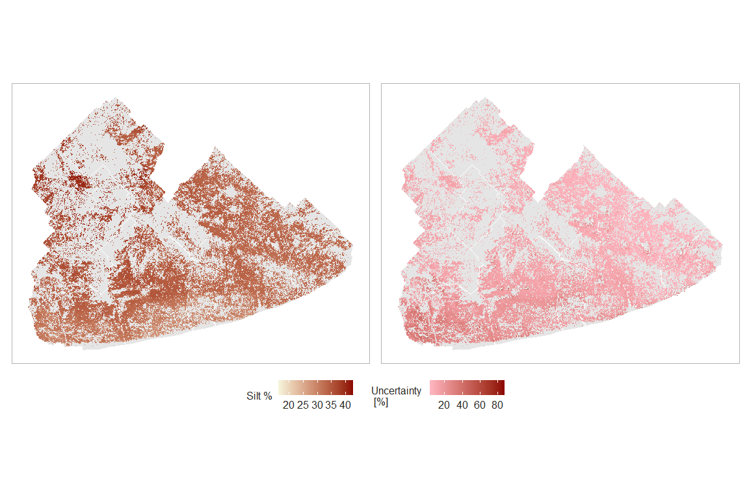

Final map and corresponding uncertainty in percent for silt_0_30

## Accuracy assessment: Silt

The section presents the map quality mesaures (i.e. accuracy indicators) associated with Silt, the relationship between observed and predicted values and the importance of the single covariates on the model accuracy using the Boruta algorithm.

### Accuracy indicators: Silt

Accuracy Indicators: Silt

| ME | MAE | RMSE | r | r2 | MEC |
| --- | --- | --- | --- | --- | --- |
| -0.08 | 2.14 | 3.55 | 0.68 | 0.46 | 0.45 |

### Observed vs Predicted: Silt

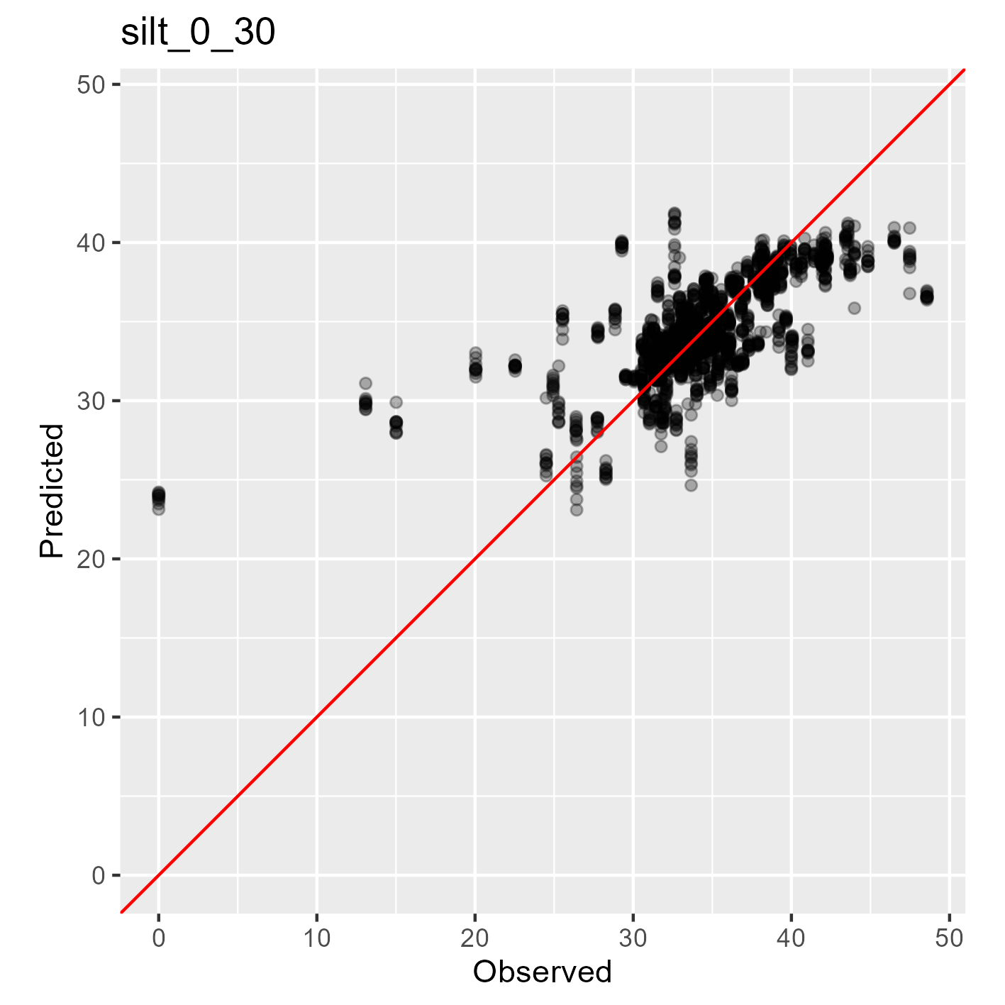

Observed vs Predicted: Silt

### Importance of the covariates: Silt

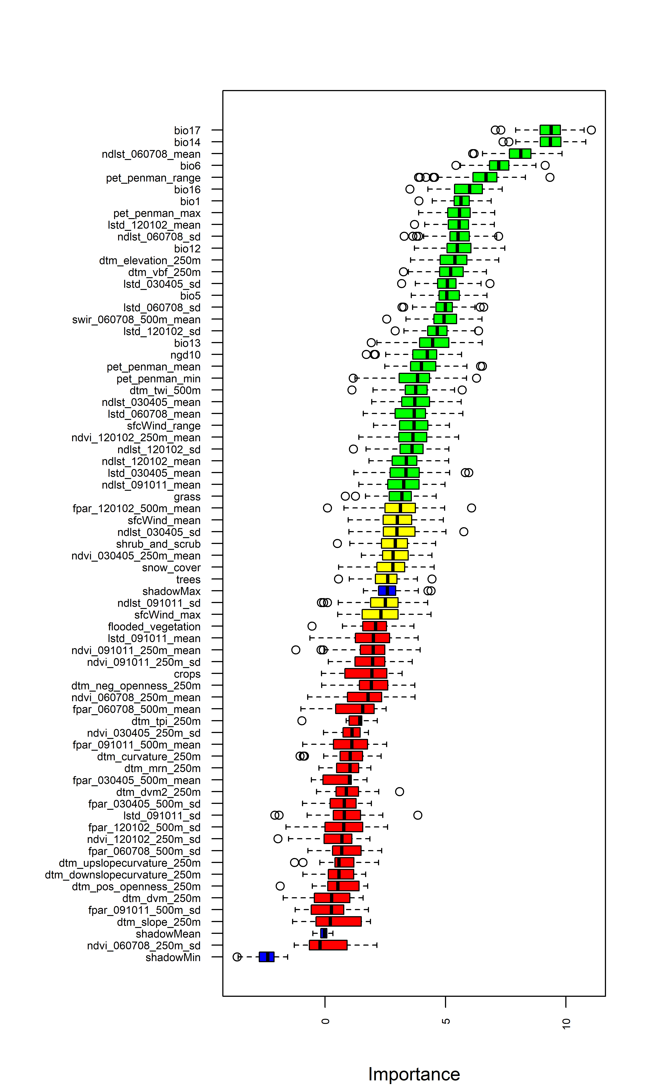

Covariate importance to the final model based on the Boruta algorithm

# References

*FAO.* 2022. Country guidelines and technical specifications for global soil nutrient and nutrient budget maps GSNmap: Phase 1. Rome. <https://doi.org/10.4060/cc1717en>